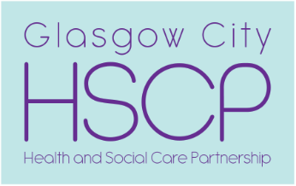  , | Chief Officer  Pat Togher  BA Social Work | Glasgow City Health and Social Care Partnership  Commonwealth House  32 Albion Street  Glasgow  G1 1LH  www.glasgow.gov.uk  www.nhsggc.org.uk

Our Ref: 20260249-DP8578185
Your Ref: 100037
Date: 06/05/2026

MMA Legal
evidence@mmalegal.co.uk

Dear MMA Legal

Request for Access to Records
Your client: Maria Mcquade

I am writing with regard to your access request on behalf of your above-named client.

Unfortunately, we are unable to progress your request for access to your client’s records, as this is a duplicate of a request from your client, submitted via Livingstone Brown which is already being progressed by our team (DP8433731).

As such, your request is declined at this stage. If your client would prefer for a request from yourself to be progressed on his behalf, he will be required to instruct Livingstone Brown to advise us they are withdrawing their request.

Complaints:
We aim to directly resolve all complaints about how we handle personal information. If your complaint is about how we have handled your request for personal information, you can contact the Council’s Data Protection Officer by email at dataprotection@glasgow.gov.uk

However, you also have the right to lodge a complaint about data protection matters with the Information Commissioner's Office, who can be contacted by post at: Information Commissioner's Office, Wycliffe House, Water Lane, Wilmslow, Cheshire, SK9 5AF. By phone on 0303 123 1113. Visit their website for more information at-
https://ico.org.uk/make-a-complaint/

Yours sincerely

Lily Utting
Administrative Officer
Complaints, FOI and Investigations Team
Glasgow City Health and Social Care Partnership

Email DataProtection@sw.glasgow.gov.uk

