PRIVATE AND CONFIDENTIAL Please ask for Nicola Williamson

MMA Legal | Email: healthsocialcarerecordsupportteam@highland.gov.uk
43-59 Princes Street | Our ref: FS-Case: 827785085
Stockport | Your ref: 100006
SK1 1RY | Date: 8th May 2026

Dear Sir/Madam

Subject Access Request
Many thanks for submitting a subject access request for your client, Amanda Golabeck, which was received by the Records Support Team.
I have enclosed the information requested however due to data protection regulations (UK GDPR) third party information including where applicable, police and NHS, has been redacted. Where possible, I have left references available to allow you to seek this information from the relevant organisation.
A link to your client’s electronic information will be sent out shortly after you have received this e-mail. If for any reason the shared link is not visible in the e-mail account provided, it is advisable to check your SPAM folder in the first instance.

If I can be of any further assistance, please do not hesitate to get in touch.

Yours sincerely
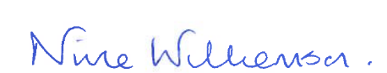

Nicola Williamson

Administrative Assistant 2
Records Support Team
Health and Social Care

