PRIVATE AND CONFIDENTIAL Please ask for Nicola Williamson | PRIVATE AND CONFIDENTIAL Please ask for Ross Fairfield
  MMA Legal | Email: healthsocialcarerecordssupportteam@highland.gov.uk
  43-59 Princes Street | Our ref: FS Case: 827785085
  Stockport | Your ref: 100006
  SK1 1RY | Date: 20th April 2026
  Email: healthsocialcarerecordsupportteam@highland.gov.uk
  Our ref: FS-Case:
  Your ref:
  Date: dd

Dear Sir/Madam

Subject Access Request

Your request for your client Amanda Golabeck’s personal data, also known as a subject access request, has been received and is now being processed by the Records Support Team.

The Highland Council are happy to assist you in accessing the information to which your client is entitled.

I will contact you again as soon as possible, and in accordance with the terms of the Data Protection Act 2018, within one month of our receipt of your request. In certain circumstances it may be a requirement to extend the timeframe to complete your files, this will be communicated with you separately.

Once the paperwork is ready, I will contact you to let you know. Your client’s files will be sent electronically, which I will share by email.

In the meantime, I would take this opportunity to inform you that Data Protection laws in the UK are regulated by the Information Commissioner’s Office (ICO). A link to the ICO’s website is provided for your convenience: https://ico.org.uk/for-the-public/

Should I be able to assist in any way throughout this process please feel free to contact the Records Support Team.

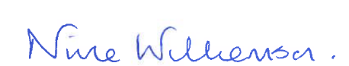
Yours sincerely

Nicola Williamson

Administrative Assistant 2
Records Support Team
Health and Social Care

