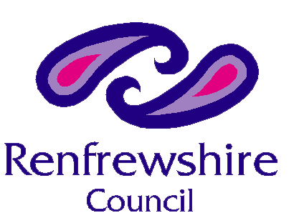

Our Ref:
Your Ref:
Contact: Courtney Kelly
E-mail subjectaccessrequests@renfrewshire.gov.uk
Date: 19th May 2026

MMA Legal
Stok, 43-59 Princes Street
Stockport
SK11RY

Data Protection Act 2018, Subject Access Request

I refer to your recent application to Children Services for access to the social care records for Elizabeth Campbell (DOB 11/03/1972)

We have now completed a thorough search which has revealed that we do not hold the documents that you have requested.

This could be because Renfrewshire Council were not the responsible Local Authority or alternatively the documents may have been destroyed due to respective retention periods.

Should you require further information please do not hesitate to contact me at the above email address.

Yours sincerely

Courtney Kelly
Quality Assurance and Data Support Officer

