SCT Acorn House Assessment Form

Name of Applicant | Colin Kerr
Interview Date | 01/10/2025
Staff Members | Ben / Colin
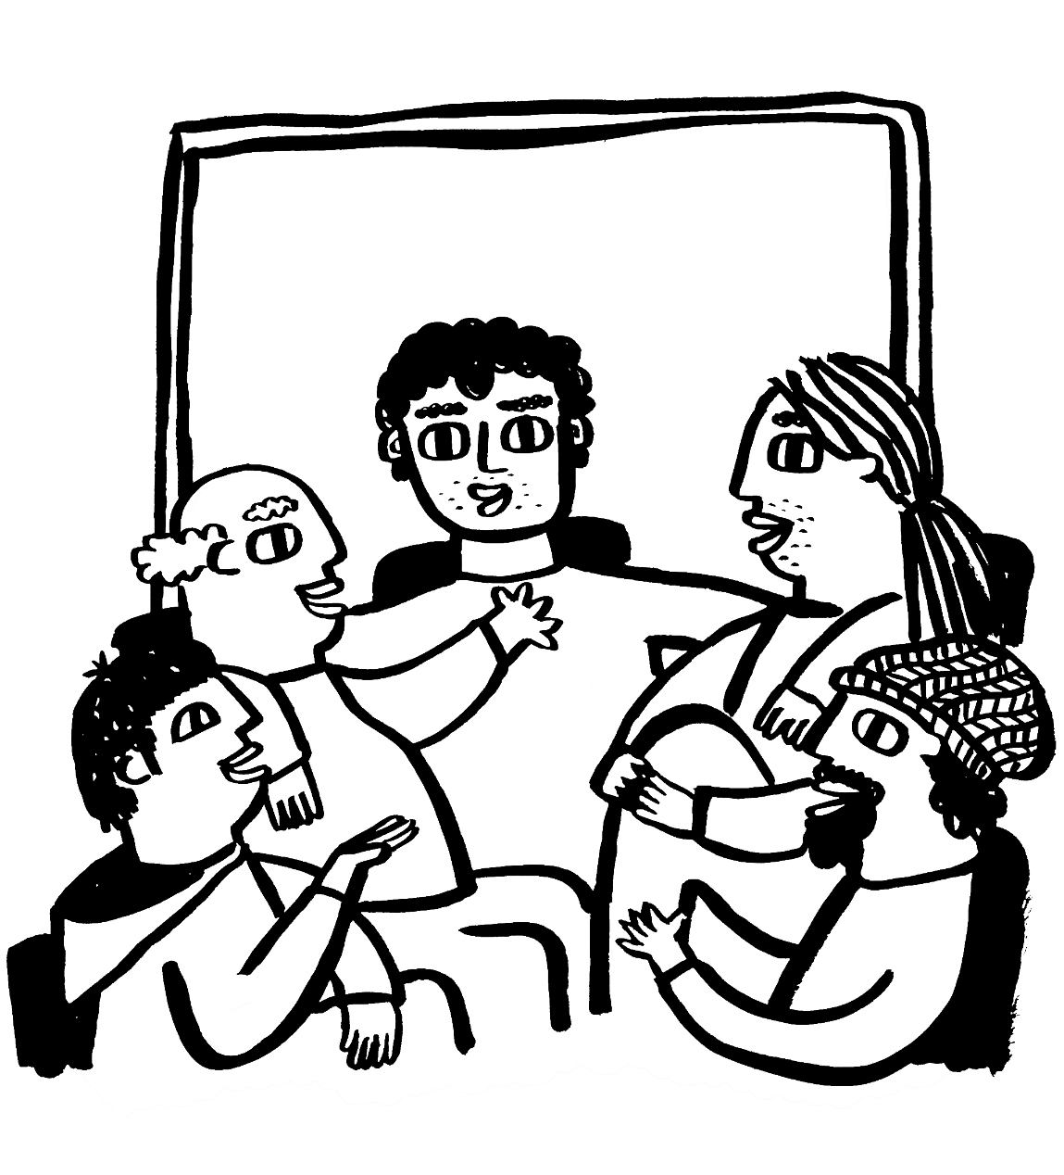

Spitalfields Crypt Trust
Acorn House, 116-118 Shoreditch High Street, London, E1 6JN
Registered charity No. 1075947
Company No. 3734793
0207 613 5677
Assessors
As an assessor, you will have read the interviewee’s Acorn House Referral Form ahead of the assessment. If the form raised an issue or highlights a concern that requires further exploration, you must not hesitate to address it during the assessment. Your discussion and conclusions can be recorded in the section headed ‘additional notes’ at the end of this form.

Programme Overview
Before commencing the assessment, please inform the interviewee the Acorn House therapeutic programme lasts 6 – 8 months and is comprised of the mandatory components set out below:

- Daily Morning reflections
- 1x one-to-one key-work session per week
- 1/2x one-to-one counselling sessions per week
- 2 x training and development classes per week
- 3 x group counselling sessions
- A fortnightly community group session
- Attend at least 4x NA/AA/CA meetings per week
- Take part in therapeutic duties as decided by the rota

Explain that whilst at Acorn they will be regularly and randomly tested for drugs and alcohol, and if they test positive for either, they will be required to leave.

Once this information has been relayed, ask the interviewee if they would like to proceed with the assessment:

Do you have a tenancy or your own property? | Yes |  | No | x

Background
When did you start using/drinking?
I started at the age of 14 using alcohol my mum was active alcoholic before she started going AA fellowship meeting. Used alcohol to take away my anxiety and made me bold.
At age 18 I started using recreational drug cocaine until when I was 27 years old my mum passed away. that was a quick catalyst because I met a guy that introduce me to inject heroin.

Do you know why you started using/drinking?
When I was 5 years old, we moved to London, and my mum met a guy called Jerry. I was timid with Scottish accent I used alcohol to cure my shyness. One day Mum Friend Jerry got into trouble and mum was drunk and unconscious, some men came for Jerry with knife to kill him- that was another catalyst. I started using alcohol to stand bold because I was a target of bully slowly, I got into the habit of using alcohol as medicine to cure shyness and that became a cycle
When did it become a problem for you?
At age 15 I became an alcoholic and got involved with car theft and was in prison .

What is motivating you to make changes in your life?
Am sick of myself and sick of the lifestyle and things that happened in my life has been a catalyst and being to rehab in 2012 and being in and out in last 15 and I think I need to try a different thing .

Addiction/s
What are you currently using/drinking?
Not currently using and drinking. I am 6 days sober.
What are the patterns of your addiction? (daily use/binge using)
Daily user
I got support from my girlfriend and very supportive
What does a day in active addiction look like for you (when at its worst)?
I was homeless in Lester and I drink very quick meaning I will need a lot of drink and that put more pressure of the number of drink I can afford to buy . I do fuel my addiction with doing all sort of things but never rob anyone at my old age rather I do shoplifting .

Have you managed any periods of abstinence in the last few years?
Yes from 2019 – 2022
I was at residential Christian rehab and a different way of rehab where they teach about Jesus, but I believe something was missing, I managed to stay clean but nothing to sustain it

Health
How would you describe your physical health?
Is good but I got issues with my knee - not painful and not taken any medication to support it. Waiting for medication investigation and to check my stomach ulcer. Apart from that I am okey.
Have you ever experienced seizures?  If yes, give details | Yes | x | No
Once related to taken ecstasy
Would you relate these seizures to your alcohol use/benzodiazepine withdrawal? | Yes |  | No | x
Are you currently being treated for any physical health issues?  If yes, give information on diagnosis/treatment | Yes |  | No | x
Are you currently experiencing chronic pain?  If yes, how is it being treated? | Yes |  | No | x
Do you have a diagnosed mental health condition?  If yes, give information on diagnosis/treatment | Yes |  | No | x
How would you describe your mental well-being at the current time?
Not drinking for 6 days and not in a best place although I am good in taking myself out and trying to find myself in a good place .

Do you experience concerning levels of anxiety?  If yes, please give more information | Yes |  | No | x
How does your anxiety affect your day-to-day life? Yes No x
Do you ever experience panic attacks? | Yes |  | No | x
Have you ever attempted suicide?  If yes, please give us as much information as you can (e.g., most recent attempt/motivation/age at first attempt, etc). | Yes |  | No | x
Are you currently feeling suicidal?  If yes, conduct a risk assessment including details of any plan/means/access to means - then signpost to a health professional (mental health crisis team/A&E) | Yes |  | No | x
Have you ever harmed yourself intentionally (without suicidal intent)?  If yes, please tell us more about this | Yes |  | No | x
Have you ever been admitted to a psychiatric hospital?  If yes, please tell us more about this | Yes |  | No | x
Once when I was coming out of methadone

Have you recently experienced significant life changes or events?  If yes, please tell us more about this | Yes | x | No
Yes in 2020 when my grandson was killed by car crash. and my daughter was arrested and charged for manslaughter.

Offending History

Do you have any convictions?  If yes, please give details | Yes | x | No
Convicted for Car theft until I was 20 during my heroine days
Convicted for Shoplifted in 2009
Arrested and convicted in 2007 for in possession of screwdriver and blade with intent to cause harm and was in prison.
In 2004 was convicted for shoplifting
The recent conviction was in 2019 where I burgled my ex-partner apartment.

Have you ever been convicted of a violent offence?  If yes, please give details | Yes | x | No
Yes the above mention conviction .

Have you ever been convicted of a sexual offence?  If yes, please give details | Yes |  | No | x
Have you ever been convicted of arson?  If yes, please give details | Yes |  | No | x
Do you have any current or outstanding NMOs or Restraining Orders?  If yes, please give details | Yes |  | No | x

Support Networks

Do you have a family or other support network?  If yes, please give details | Yes | x | No
Yes, I have 3 children and my sister.
( 2 daughters and 1 son and sister) aged 22, 23. AND 25 YEARS OLD .
Do you have children?  If yes, please give details | Yes |  | No
Yes, I have 3 children and my sister.
( 2 daughters and 1 son and sister) aged 22, 23. AND 25 YEARS OLD.

Do you have contact with your children?  If yes, please give details | Yes | x | No
Only in contact with 1
Morgan

Are Social Services involved in their care?  If yes, please give details | Yes |  | No | x

Day to Day

Do you have ID (e.g., birth certificate, passport, driving licence)?  If yes, specify details | Yes | x | No
Do you have evidence of your NI number?  If yes, specify | Yes |  | No | x
Are you in receipt of benefits?  If yes, specify | Yes | x | No
Uc

If you receive UC, do you know your log-in details?  If yes, specify | Yes | x | No
Have you recently had a medical assessment (within the last three months)?  If yes, give details | Yes | x | No
Do you need to provide fit notes? | Yes | x | No
Do you have access to online banking (to access your bank statements)? | Yes | x | No
Have you ever been evicted?  If yes, state when and for what reason/s | Yes | x | No
Have you been in rent arrears?  If yes, give details | Yes | x | No
Last flat I left never paid last couple month

Do you have any upcoming appointments (e.g., court dates, medical appointments, etc)?  If yes, give details | Yes | x | No
But not date schedule yet

What medications do you currently take? How much and for what condition/s? If yes, provide details | yes | x | No
Omeprazole

Lifestyle

Do you have any allergies or other dietary requirements? If yes, give details | Yes |  | No | x
Do you consider yourself to be spiritual or religious?  If yes, please describe your faith/beliefs | Yes | x | No
Christian.
What are your strengths

Pretty positive, encouraging and very punctual

Additional Notes

