PRIVATE AND CONFIDENTIAL Please ask for Ross Fairfield

MMA Legal | Email: HealthSocialCareRecordsSupportTeam@highland.gov.uk
 | Our ref: FS-Case: 831330915
 | Date: 27th April 2026

Dear sirs

Subject Access Request
Many thanks for submitting a subject access request on behalf of your client Angela Cross, which was received by the Records Support Team.
After an extensive search of both our electronic and paper archives, I was unable to locate any information relating to your client.

I then consulted with our senior archivist who has managed to locate the following school register extract:

Ref: HCA/Acc.3302/12
Inverness County Council Application Register – Children Coming Into and Discharged From Care, 1966-1981
Children in Institutions (Rosedene) for Year Ending 31st March 1980
Name: CROSS, Angela
Date of Admission to Institution: 07/06/79
Date of Birth: 22/05/67 (NB: the details provided by the solicitor in the SAR give dob as 22/02/67 but copy of passport has correct date of May)
Sex: F
Date of Leaving Institution: 29/06/1981

As I am unable to provide you with anything further at this time, I will mark this case as complete on our system.

If I can be of any further assistance, please do not hesitate to get back in touch.

Yours sincerely
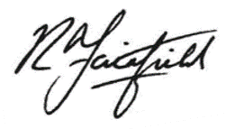

Ross Fairfield

Records Support Officer
Records Support Team
Health and Social Care

