Our Ref:  Your Ref:  Contact:  E-mail:  Date: | AG/NMcG/AT  Sarah Shields  ChildrenFamiliesGeneralAdmin@northlan.gov.uk  21 July 2026
Private & Confidential  Investigations Team  MMA Legal Ltd  STOK, 43-59 Princess Street  Stockport  SK1 1RY  Email: evidence@mmalegal.co.uk  Dear Sir/Madam |  |  | Education & Families  Alison Gordon  Chief Social Work Officer (Education, Families, Justice and Integrated Practice)  Civic Centre  Windmillhill Street,  Motherwell ML1 1AB  www.northlanarkshire.gov.uk
Subject Access Request – Kevin Sexton, DOB: 31/8/1952

Thank you for your request for access to Kevin Sexton’s personal information under the Data Protection Act 2018 or the General Data Protection Regulation dated 10 July 2026.

Your request is being progressed by Sarah Shields, Social Worker, Fostering & Adoption Team, Carers Centre, 7 Mitchell Street, Airdrie, ML6 0EB. Email: CarersTeamGeneralAdmin@nlc.gov.uk. You may contact Sarah if you have a question about your request.

We have considered your request and are searching for information relating to Kevin Sexton. However, due to the volume and complexity of the information requested, it is clear at this stage that it will taking longer than one month for us to respond to your request, and it may take us up to three months.

As this is the situation, you can expect a response by 11 October 2026 although we will try to have the response ready for you earlier.

Please note that an individual is entitled to a copy of their own personal information but not necessarily to the document in which that information is contained. The response we send you will contain a description of the personal data that we hold. The response may not contain a full copy – redacted or otherwise – of the original records that we hold.

If/…

If you are not happy with our response to your request, you can ask us for a review of your request. You also have the right to complain to the Information Commissioner’s Office or seek judicial remedies. Information is available on the Information Commissioner’s website at https://ico.org.uk/your-data-matters/raising-concerns/
Yours sincerely

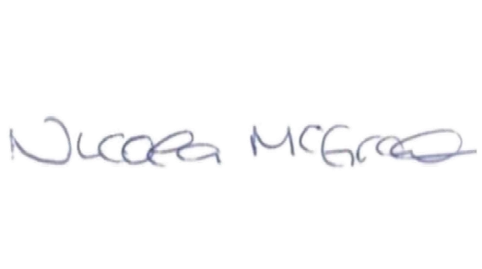
Nicola McGrath
Education & Families Manager

