PRIVATE AND CONFIDENTIAL Please ask for Ross Fairfield

MMA Legal | Email: HealthSocialCareRecordsSupportTeam@highland.gov.uk
 | Our ref: FS-Case: 857025357
 | Your ref:
 | Date: 16th July 2026

Dear sirs

Subject Access Request
Many thanks for submitting a subject access request on behalf of your client Maureen Reid, which was received by the Records Support Team.
I have enclosed the information requested on the next page.
If I can be of any further assistance, please do not hesitate to get in touch.

Yours sincerely
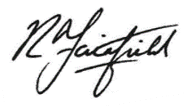

Ross Fairfield

Records Support Officer
Records Support Team
Health and Social Care

Central School admission register 1956-62 (Ref: CI/5/3/174p)
Admission No.: 38.59
Date of admission: 28/04/59
Name: McLean, Maureen
Date of birth: 10:01:54
Address: Rosedene, Inverness
Name of Parent/Guardian: Matron
Relationship: Guardian
Name of last school: Foyers J.S. [Junior Secondary]
Class entry: I(2)
Class at leaving: I(1)
Date of withdrawal: 25/09/59
Reason for withdrawal: To England

