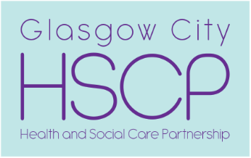 | Chief Officer  Pat Togher  BA Social Work | Glasgow City Health and Social Care Partnership  Commonwealth House  32 Albion Street  Glasgow  G1 1LH  www.glasgow.gov.uk  www.nhsggc.org.uk

Our Ref: 20260416-DP8566434-MMAL
Your Ref: 100016
Date: 16 April 2026

MMA Legal
43-59 Princes Street
Stockport
SK1 1RY

Dear Sirs

Request for Access to Records
Your client: Deborah Sullivan

I am writing with regard to your access request on behalf of your above-named client, received on 15 April 2026.

Unfortunately, we are unable to progress your request for access to your client’s records, as this is a duplicate of a request we received from you on 10 April 2026 (DP8564546).

As such, your request is declined at this stage. If your client would prefer for a request from yourself to be progressed on his behalf, he will be required to instruct SNK Solicitors to advise us they are withdrawing their request.

Complaints:
We aim to directly resolve all complaints about how we handle personal information. If your complaint is about how we have handled your request for personal information, you can contact the Council’s Data Protection Officer by email at dataprotection@glasgow.gov.uk

However, you also have the right to lodge a complaint about data protection matters with the Information Commissioner's Office, who can be contacted by post at: Information Commissioner's Office, Wycliffe House, Water Lane, Wilmslow, Cheshire, SK9 5AF. By phone on 0303 123 1113. Visit their website for more information at-
https://ico.org.uk/make-a-complaint/

Yours faithfully

Lorna Fitzpatrick

Lorna Fitzpatrick
Resource Worker
Complaints, FOI and Investigations Team
Glasgow City Health and Social Care Partnership

If phoning or visiting, please ask for Lorna Fitzpatrick
Telephone 07741291366
Email DataProtection@sw.glasgow.gov.uk

