PRIVATE & CONFIDENTIAL

Mr Alexander McNeil
1 Moss Road
Fallin
FK7 7JF

24th July 2026

Dear Alexander,

Re: Aiker Legal Invoice – Redress Scotland

Please find attached our invoice in respect of professional legal services provided to you in relation to the above matter.

The invoice covers work undertaken by us, including but not limited to:

- Acting on your behalf
- Redress Scotland application completion - additional information processing
- Evidence gathering and submissions
- Liaison with Redress Scotland Caseworkers
- Advice on Redress decision pack and waiver
- Post‑decision client care

The total amount due is inclusive of VAT as indicated on the invoice. This invoice is issued in accordance with our Non-Contentious Business Agreement.

Payment is required by 4th August 2026 and may be made by bank transfer. Please refer to our account details at the foot of the invoice. Please use AMcNeil /AIK-10 as the reference when making your payment.

Thank you for placing your trust in us. If you have any questions or require any additional information regarding the invoice, please do not hesitate to contact us and we will be happy to help.

Yours sincerely,
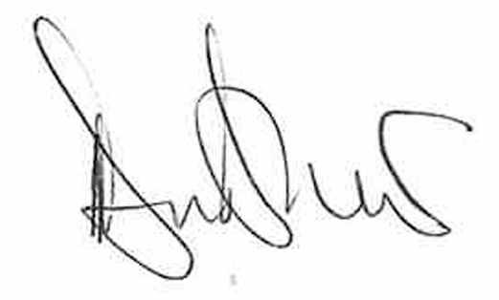
Deanna Bradshaw
Aiker Legal Support Team

