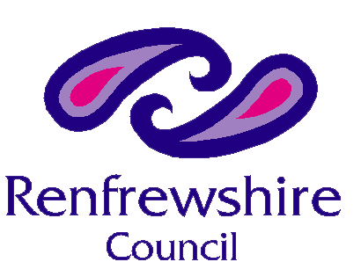
Our Ref:
Your Ref:
Contact: Lindsay Douglas
Email: subjectaccessrequests@renfrewshire.gov.uk
Date: 13th January 2026

Raymond Baker
Aiker Legal Ltd
4a Edison Court, Elice Way,
Technology Park,
Wrexham,
LL13 7YT

Dear Raymond,

Data Protection Act 2018, Subject Access Request

I refer to your recent application to Children Services for access to the social care records of Morag Hainey, DOB: 2/11/1966.

The files requested have now been prepared and are enclosed. Any information which has been redacted is personal information belonging to another person and we are under law obliged to remove this.

The information in this file is of a personal and highly sensitive nature and all care should be taken to ensure the information contained within the files is handled with care.

The personal data generated by this enquiry will be retained only as long it is required to process the enquiry, and for statistical analysis of the Council’s processing of such enquiries more generally. The data will not be used for any other purpose.

Should you require further information please do not hesitate to contact me at the above email address.

Yours sincerely

Lindsay Douglas
Data Solutions Officer

