CARDROSS PARK CHILD RESOURCE CENTRE
REVIEW REPORT on
PETER NOBLE (DOB 1B 11 77) 2 Cedar View, Roseneath
Section: 44(1) (b) Cardross
Last Review: 14 5 92
DECISIONS
I Peter to remain in Car-dross.
- Community Parents — To await outcome of screening meeting.
- Mainstream schools to be investigated
- Pursui ts outwith Centre to be pursued.
Since the last review Peter has started attending Our Lady & St Pat's. Initially Peter had problems in settling into the routines necessary for attending mainstream school. However, he overcame this, and, according to reports received, responded well to school routines and discipline.
Unfortuna tely on 14 September, 1992, an Incident occurred within the school which resulted in Peter assaulting another pupil and he was subsequently suspended for a three day period.
Within the Centre Peter causes no management problem, which is to his credit given the length of time Peter has been resident here and the emotional pressures he is under. peter has been rather subdued lately, this possibly due to the fact he does not see that there has been any progress made regarding community parents or an interim Placement.
Peter had a visit from Alex Neil, from the Family Finding Team, he did not show any real enthusiasm after this visit since he was of the opinion that it was just more talking and no real action.
It has proved difficult to get Peter interested in any activity outwith the Centre, which he would have to attend on his ov•m. He felt rather vulnerable, having to face yet another strange situation on his own. Recently, however, he has started attending a boxing club in Renton Youth Club. He is attending in the company of a friend from school. The boy's parents are aware of Peter'S present circumstances and are agreeable to Peter accompanying their son and have also very kindly asked Peter to tea in their home one night per week.
FAMILY SITUATION
Due to Mrs Noble's present circumstances she finds it difficult to visit Peter. She does however telephone whenever possible, and Peter really looks forward to these telephone calls .
Peter still finds it extremely difficult to accept what he sees as his mother 's rejection of him. He also finds it very difficult to discuss the situation, putting up a very defensive front whenever the subject is broached.
Although/...
2
PETER NOBLE
Although in the recent past Peter has been adamant about not wanting to contact his father, he is now stating he will write to him to see if he will offer him a home. This more than anything would emphasis how dejected Peter is feeling at this moment.
CONCLUSION
At this particular time Peter is finding it difficult to accept his present situation. He is of the opinion that no one is making any real effort on his behalf. It is the writer's opinion that Peter's needs can, to a limited extent, be met at Cardross. Therefore the review must address the need for Peter
to progress from Cardross, and discuss the options available.

ANNE GILLESPIE | THOMAS P KELLY
ASSISTANT ASSESSMENT OFFICER | A/SENIOR ASSESSMENT OFFICER

18 9 92
4 9 92isit to Cardross — discussed above issue with Ann Gillespie and looked at ways to approach Peter on his general attitude towards people and specifically women. Ann explained that Peter had been receiving telephone calls from a girl called Asked Ann to find out if the girl in question was — explained Peter 's past involvement with to Ann and dangers involved in such a relationship.
7 9 92T/C from Cardrosg A phone call had been received from Our Lady and St Patricks. Peter not at school today. Keyworker to discuss this with him when he returns tonight.
J Docherty/AMC
wgsos
Peter Noble
They involved another young person living in Rosneath —
12 6 92 Meeting at Cardross with peter, Ann Gillespie, Stuart Miller (Senior IT
Clydebank) re possible inclusion of Peter on Ocean Youth Club trip 27—30 July.
26 6 92 Letter received from Family Finding — difficulty with Peter expressing fervent desire to remain in Dumbarton area. There are at the moment no community parents in our area.
- 6 92 Meeting With Peter at Cardrogs to discuss the issue raised by Family Finding. Peter now agrees that he would move anywhere in Strathclyde except Troon. He refuses to explain his problem with Troon.
Informed Family Finding of Peter 'g decision — referral will go ahead and a family to be identified.
- 6 92 T/C to Rosemary Finnigan — Peter has attended Our Lady and St Patrickg for one week now and appears to be trying hard to integrate himself with the school system.
Summary
Current situation is that Peter remains in Cardross under 44 (I ) (b) Family Finding are actively pursuing the referral and an initial meeting will be set up to introduce the worker to Peter. Rosemary Finnigan is now involved supporting Peter in mainstream school .
7 7 92 Joint meeting at Cardross — Ann Gillespie, Peter, Rosemary Finnigan and Joe Docherty. Rosemary sent apologies — meeting continued — Peter gaying he would like to be moved to a childrens home. Ann Gillespie supported him in thi3 saying she had noticed it was becoming more difficult for Peter to sustain hig good behaviour and he had recently become more sullen and taciturn.
21 7 92 Letter to Stuart Miller confirming OYC trip.
27—30 July Peter on OYC trip.
29 7 92 T/C to Ann Gillespie — Peter still eager to move to childrens home.
- B 92 Visit to Cardross — discussion with Peter re OYC. Apparently Peter enjoyed his time there and gained a lot from it in terms of gel-f esteem.
- 8 92 T/C to Family Finding — family still trying to be identified. Arranged visit to Cardross for Alex Neil Family Finding worker.
TIC, to CArdross advising of above
T/C to Rosemary Finnigan — Peter continuing to make progress at school, has been included in groupwork.
11 8 92 Meeting at Cardross with Ann Gillespie, Peter and Alex Neil, Peter happy for referral to continue .
4 9 92 T/C to Our Lady and St Patricks — spoke to Susan Aitken, Guidance, happy with Peter's progress, he seems to be trying hard. He hag had some difficulties but goes to guidance with them and discusseg ways forward. Susan feels sometimes his attitude is obsequious with women ie complimenting her on her perfume etc. This issue will be taken up with Peter through myself, Ann Gillespie and Rosemary Finnigan.

25 3 92 Assessment conference — see report and summary of discussion.
It
Dates for IT' group meetings
Feb 25
March 3
March 10
March 17
See IT workers review report
Summary
Peter ^{i} s home situation has deteriorated to the point where he was received into care in Blairvadach. Since that time contact with his mother has been sporadic
Assessment at Cardross will provide Peter and SWD insight into his problems and allow a plan to be formulated with regard to hiS future. Recommendation of assessment conference was that further investigation of following areas would be required before definite plan could be formulated.
- clarification re feasibility Of obtaining community parents
- attempts to be made with a view to getting mother and son together again
- discussion with Joe Nee ( Psychologist) to ascertain what could be arranged to meet the need for alternative education.
g a 92 New hearing convened — supervision order granted 44(1) (b) naming
Cardross.
- 4 92 Home visit to Rosneath — no one at home.
- 4 92
30 4 92

12 5 92
BAAF form completed and sent off.
14 5 92 Assessment review — see minutes and summary of discussion.
18 5 92 Meeting with Peter, Joe Nee and Ann Gillespie at Cardross felt that attempts should be made to reintegrate Peter in mainstre school. With a view to exploring this possibility agreed to refer to YPIT Project.
29 5 92 eeting with Rosemary Finnigan, YPII' worker. Agreed to explore ossibility of inclusion for Peter in Dumbarton Academy or Our Lady d St patricks.
4 6 92 Letter from Reporter allegations of theft and contravention Of exual offences act have been considered and no further action e taken. This charge related to incidents which allegedly ecurred whilst Peter had absconded from Blairvadach.
peter Noble
- 2 92
- 2 92 DASU — decision taken to admit Peter to Cardrcss Assessment Centre on Sect 43(4) for assessment.
6 2 92 Child Care Review — gee Fom D and minutes.
11 2 92

17 2 92 T/C Blairvadach — Blairvadach saying Peter expressing concerns over not having had visit from mum. Advised Blairvadach that contract over visits should be drawn up between Peter and Mum in order to reduce Peter's anxiety.
22 2 92 Home visit — present Mrs Noble, Peter, Joe Docherty. Peter had absconded from
Blairvadach and wag f0Und by the writer in the family home with his mother. On the return to Blairvadach Peter explained that he had run away in order to gee his mum who he wag worried about — he still felt Bill was putting pressure on Mum not to visit him.
- 2 92 Visit to Blairvadach with Peter — after discussion with Peter regarding his offending behaviour Peter admitted he had been involved in a housebreaking with 2 other boys from Helensburgh. Of his own volition he decided to present himself at Helensburgh Police Station and admit to what he had done and give the police any information which they might find helpful in their investig— ation.
- 2 92 Accompanied Peter to Helensburgh Police Station for the above purpose. Peter willingly gave police honest answers to their questions.
- 2 92 Childrens Hearing — Peter was placed on a 43(4) awaiting a place at Cardross Assessment Centre.
6 3 92 Child Care Review — see minutes
Transfer to Cardross Child Resource Centre
g 3 92 Proposed Childrens Hearing cancelled.
12 3 92 Childrens Hearing — hearing continued.
Letter sent from Cardross inviting to assessment conference .
23 g 92 Visit co Cardross — Peter not particularly happy but beginning to accept situation

at home.
Letter hand delivered to

inviting her to assessment conference.
Peter complained about putting his girlfriend out of the house the other night. I asked why this happened and replied when they lived in the caravan at Rosneath Caravan Park Peter and the girl he was seeing at that time used to barricade themselve in Peter' g bedroom and 'bang away like rabbits' She said she put a stop to this by not allowing the girl back into the caravan. Although she couldn't be sure she felt the same thing was happening with Peter and his current girlfriend who is 16 years. She theref decided that the best thing to do was to keep the girl out of the house al together. I asked had discussed sexual behaviour with him and she says that she hadn and concerned any girl of 16 years who has sex with a boy is a glut. pointed out that I didn 't agree with her but understood her concerns over Peter's sexual activities. We agreed that Joe Docherty (SW) would probably be the best person to discuss thig issue with Peter, Peter seemed quite happy with this suggestion.
far
as
Rietveld/
AMC
Peter said that he couldn't understand why his mother had changed her mind as he felt the tuation had not changed since the workers last visit with Joe Docherty on
During interview 1 gained the $rnpresslon that the relationship betw en Peter and his mother was strained.
2 occasions and remarked that things would be better at home if pet r hanged his attitude and made more of an effort.

17 12 91
Peter spoke briefly about his relationship with Bill . He explained that they have never really got on and that always makes promises and never keeps them.
14 1 92 
ter
disagreed
his mother stating that things were still the same at home.
angry with Peter insisting that he try harder to get on with explained that Peter goes out of his way to cause trouble at home and with and at one point said that if Peter should leave the family home she would be under less pressure .


17 12 91 oint visit — Joe Docherty, Dot Rietveid,and Peter — ee attached notes.
13 1 92 upwork with Peter. Peter was upset and distressed at the group ue he said to the deteriorating relationship at home with his mother. Opportunity to talk more freely outwith the group as provided when he was being returned home after the group. Pete aid he felt that was putting pressure on his mother and urning her against Peter.
23 1 92 Office visit bypresent J Docherty and Burke, Area Manager.
came to the office explaining that Peter had un away from home and that he had broken into a caravan parked utside the family home which they were caretaking for a friend.
did not want Peter to eturn home and that when found he should be taken into care. It xplained that the departments view was that support would continue be offered to the family and that Peter should remain at home ilst work continued on family relationship problems, Peter 's nvolvement. in offending behaviour and his difficulties at school.
eter as a difficult child from birth, said that he was hyperactive d disruptive as an infant and that he had been uncontrollable hroughout his life.
efuse to have Peter back home against departmental advice she could e Hegarded as having abandoned and he may be received into are un&r a place of safety order.
25 1 92Peter was received into care in Blairvadach Childrens Home by
Standby workers under Section IS of the Social Work (Scot) Act .
24—31 1 92 worker on annual leave.

19 11 91 T/C from Mrs Mair ( Guidance Teacher, Hermi tage) Mrs Mair hag advised to come along to SWD following concerns expressed by Mrs Noble and herself over Peter's non attendance at school and offending behaviour in the community. Peter has been attending IT group (see groupwork recordings ) .
10 12 91 Home visit — present Peter Following discussion on family history and circumst:ances the following statements were made by and
Peter.
Peter Peter's father left home just before Christmas 1987 leaving and himself —
Peter and his mother moved from Hartlepool where they were living to Rosneath.
The family eventually moved into a caravan in Rosneath when
reacted against Peter's lack of progress in school by keeping him in his room and making him do school exercises. When peter wag unable to complete these to satisfaction he was beaten. Peter ran away from home and returned to his father in Hartlepool .
Peter returned home after his father threw him out. Hig attendance at gchool since that time hag been sporadic although he has made attempts to remedy thig.
Petere although he is 14 years old, is a well built and tall boy who looks much older than his years. He gays that as a result of this and his lack of progress at school/ that he is the subject of bullying.
Assessment
Peter has had little consistency and few adequate controls placed upon him throughout the various developmental stages of hie life leading towards his ado 1 egcence. The main objective towards change for peter should be to provide him with consistency of approach and stability and support him through this.
a 9 92isit to Cardross — discussed above Issue with Ann Gillespie and looked at ways to approach Peter on his general attitude towards people and specifically women. Ann explained that Peter had been receiving telephone calls from a girl called Asked Ann to find out if the girl in question was — explained Peter past involvement with to Ann and dangers involved in such a relationship.
7 9 92T/C from Cardrosg A phone call had been received from Our Lady and St patricks. Peter not at school today. Keyworker to discuss this with him when he returns tonight.
J Docherty/AMC
They involved another young person living in Rosneath —
12 6 92 Meeting at Cardross with Peter, Ann Gillespie, Stuart Miller (Senior IT
Clydebank) re possible inclusion of Peter on Ocean Youth Club trip 27—30 July.
26 6 92 Letter received from Family Finding — difficulty with Peter expressing fervent desire to remain in Dumbarton area. There are at the moment no community parents in our area.
- 6 92 Meeting with Peter at Cat-dross to discuss the issue raised by Family Finding. Peter now agrees that he would move anywhere in Strathclyde except Troon. He refuses to explain hig problem with Troon.
Informed Family Finding of Peter's decision — referral will go ahead and a family to be identified.
- 6 92 T/C to Rosemary Finnigan — Peter has attended Our Lady and St Patrickg for one week now and appears to be trying hard to integrate himself wi th the school system.
Surnmarx
Current situation is that Peter remains in Car-dross under 44 ( I) Family Finding are actively pursuing the referral and an initial meeting will be get up to introduce the worker to Peter. Rosemary Finnigan is now involved supporting Peter in mainstream school.
7 7 92 Joint meeting at Cardross — Ann Gillespie, Peter i Rosemary Finnigan and Joe Docherty. Rogemary sent apologies — meeting continued — Peter saying he would like to be moved to a childreng home. Ann Gillespie supported him in this saying she had noticed it: was becoming more difficult for Peter to sustain hig good behaviour and he had recently become more sullen and taciturn.
21 7 92 Letter to Stuart Miller confirming OYC trip.
27—30 July Peter on OYC trip.
29 7 92 T/ C to Ann Gillespie — Peter still eager to move to childrens home.
- 92 Visit to Cardross — di scusgion with Peter re OYC. Apparently Peter enjoyed his time there and gained a Lot from it in terms of gel f egteem.
- e 92 T/C to Family Finding — family still trying to be identified. Arranged visit to Cardross for Alex Neil Family Finding worker.
T/C to CA?dross advising of above.
TIC to Rosemary Finnigan Peter continuing to make progress at school, has been included in groupwork.
11 8 92 Meeting at Cardross with Ann Gillespie, Peter and Alex Neil, Peter happy for referral to continue .
4 9 92 T/C to Our Lady and St Patricks — spoke to Susan Aitken, Guidance, happy with Peter's progress, he seems to be trying hard. He has had some difficulties but goes to guidance staff with them and discusses ways forward. Susan feels sometimes his attitude is obsequious with women ie complimenting her on her perfume etc. This issue will be taken up with Peter through myself, Ann GiL1espie and Rosemary Finnigan.

25 3 92 Assessment conference — see report and summary of discussion.
Dates for IT group meetings :— Feb 25
March 3
March 10
March 17
See IT workers review report
Summary
Peter's home situation has deteri orated to the point where he was received into care in Blairvadach. Since that time contact with his mother has been sporadic
Assessment at Cardross will provide Peter and SWD insight into his problems and allow a plan to be formulated with regard to his future. Recommendation of assessment conference was that further investigation of following areas would be required before definite plan could be formulated.
1 ) clarification re feasibility of obtaining community parents
- attempts to be made with a view to getting mother and son together again
- discussion with Joe Nee ( psychologist) to ascertain what could be arranged to meet the need for alternative education.
9 92 New hearing convened — supervision order granted 44(1 ) (b) naming Cardross.
27 4 92 Home Visit to Rosneath — no one at home.
2B a 92
30 a 92

12 5 92
BAAF form completed and sent off.
14 5 92 Assessment review — see minutes and summary of discussion.
1B 5 92 Meeting with Peter, Joe Nee and Ann Gillespie at Cardross. It was felt that attempts should be made to reintegrate Peter in mainstre school. With a view to exploring this possibility agreed to refer to YPIT Project.
29 5 92 eting with Rosemary Finnigan. YPII' worker . Agreed to explore ossibility of inclusion for Peter in Dumbarton Academy or Our Lady d St Patricks.
4 6 92 Letter from Reporter — allegations of theft and contravention Of exual offences act have been considered and no further action to e taken. This charge related to incidents which allegedly ecurred whilst Peter had absconded from Blairvadach.
W950ä
- 2 92
- 2 92 DASU — decision taken to admit Peter to Cardrcsg Assessment Centre on Sect 43(4) for assessment,
6 2 92 Child Care Review — see Forn D and minutes.

11 2 92
17 2 92 T/C to Blairvadach Blairvadach saying Peter expressing concerns over not having had visit from mum. Advised Blairvadach that contract over visits should be drawn up between Peter and Mum in order to reduce Peter's anxiety.
22 2 92 Home visit — present Peter, Joe Docherty. Peter had absconded from
Blairvadaeh and wag found by the writer in the family home with his mother. On the return to Blairvadach Peter explained that he had run away in order to gee his mum who he wag worried about — he still felt Bill was putting pressure on Mum not to vigit him.
- 2 92 Visit to Blairvadach with peter — after discussion with Peter regarding his offending behaviour Peter admitted he had been involved in a housebreaking with 2 other boys from Helensburgh. Of his own volition he decided to present himself at Helensburgh Police Station and admit to what he had done and give the Police any information which they might find helpful in their investig— ation.
- 2 92 Accompanied Peter to Helengburgh police Station for the above purpose. Peter willingly gave Police honest answers to their questions.
- 2 92 Childrens Hearing — Peter was placed on a 43(4) awaiting a place at Cardross Assessment Centre.
6 3 92 Child Care Review — see minutes
Transfer to Cardrosg Child Resource Centre
9 3 92 Proposed Childreng Hearing cancelled.
12 3 92 Childreng Hearing — hearing continued.
Letter gent from Cardross inviting to assessment conference.
23 3 92 Visit to Cardross — Peter not particularly happy but beginning to accept situation

at home.
Letter hand delivered to

inviting her €0 assessment conference.
Peter complained about putting his girlfriend out of the house the other night. I asked why this happened and replied that when they lived in the caravan at Rosneath Caravan Park Peter and the girl he was seeing at that time used to barricade themselve in Peter's bedroom and 'bang away like rabbits' She said she put a stop to this by not allowing the girl back into the caravan.
Although she couldn't be sure she felt the same thing was happening with Peter and his current girlfriend who is 16 years. She therefo decided that the best thing to do was to keep the girl out of the house altogether. I asked had discussed Peter ^{I} s sexual behaviour with him and she says that she hadn 't and that as far as
I pointed out that I didn agree with but understood her concerns over Peter's sexual activities. We agreed that Joe Docherty (SW) would probably be the best person to discuss this issue with Peter. Peter seemed quite happy with this suggestion.
Peter said that he couldn't understand why his mother had changed her mind as he felt the situation had not changed since the workers last visit with Joe Docherty on
During interview I gained the impression that the relationship betw en Peter and his mother was strained.
2 occasions and remarked that things would be better at home if Pet r changed his attitude and made more of an effort.
RietveId/AMC
.1
wesoa


17 12 91
Peter spoke briefly about his relationship with Bill. He explained that they have never really got on and that always makes promises and never keeps them.
14 1 92 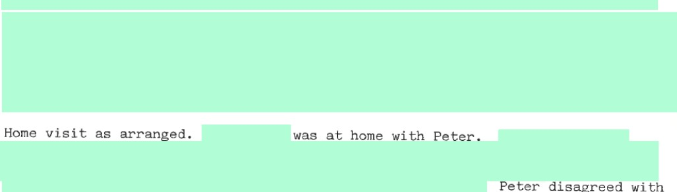
ter
disagreed
his mother stating that things were still the same at home.
angry with Peter insisting that he try harder to get on with explained that Peter goes out of his way to cause trouble at home and with and at one point said that if Peter should leave the family home she would be under less pressure .


17 12 91 oint visit — Joe Docherty, Dot Rietveld, and Peter —
ee attached notes .
13 1 92 roupwork with Peter. Peter wag upset and distressed at the group ue he said to the deteriorating relationship at home with d his mother. Opportunity to talk more freely outwith the group s provided when he was being returned home after the group. Pet aid he felt that was putting pressure on his mother and urn ing her against Peter.
23 1 92 Office visit bypresent J Docherty and Burke, Area Manager.
came to the office explaining that Peter had un away from home and that he had broken into a caravan parked utside the family home which they were caretaking for a friend.
did not want Peter to eturn home and that when found he should be taken into care. It wa xplained that the departments view was that support would continue be offered to the family and that Peter should remain at home hi 1st work continued on family relationship problems, peter 's nvol vement. in offending behaviour and his difficul ties at school.
eter as a difficult child from birth, said that he was hyperactive d disruptive as an infant and that he had been uncontrollable ughout his life.
efuse to have Peter back home against departmental advice she could e •regarded as having abandoned and he may be received into are a place of safety order.
25 1 92Peter was received into care in Blairvadach Childrens Home by
Standby workers under Section 15 of the Social Work (Scot) Act .
24—31 1 92 worker on annual leave.

W9SOS
Peter Noble
19 11 91 TIC from Mrs Mair ( Guidance Teacher, Hermi Cage) . Mrs Mair has advised to come along to SWD following concerns expregsed by Mrs Noble and herself over Peter's non attendance at school and offending behaviour in the community. Peter has been attending IT group (gee groupwork recordings).
10 12 91 Home visit — present Peter Following discussion on family history and circumstances the following statements were rnade by and
Peter Peter 's father left home just before Christmas 1987 leaving and himself —
Peter and his mother moved from Hartlepool where they were living to Rogneath.
The family eventually moved into a caravan in Rosneath when
reacted against Peter's lack of progress in school by keeping him in his room and making him do school exercises. When peter wag unable to complete these to satisfaction he was beaten. peter ran away from home and returned to his father in Hartlepool .
Peter returned home after his father threw him out. His attendance at school since that time has been sporadic although he has made attempts to remedy this.
Peter, although he is 14 years old, is a well built and tall boy who looks much older than his years. He says that as a result of this and his lack of progress at school, that he is the subject of bullying.
Assessment
Peter has had little consistency and few adequate controls placed upon him throughout the various developmental stages of hig life leading towards his adolescence The main objective towards change for Peter should be to provide him with consistency of approach and stability and support him through this.

PETER NOBLE - CASE NOTES

13.7.93 TC -spoke to Burnside Staff and said I had been asked to take over Peter's case. Spoke briefly to Peter on the phone and arranged to see him tomorrow in Helensburgh when he is visiting his girlfriend.
14.7.93 Office visit - met Peter and had a coffee, basically talked about his experiences in care and what had happened to him in terms of his family. Also discussed school a bit; Peter said he would return but this would seem doubtful considering his long long absence. Hugh Adam the Keyworker is going to call with Peter at the office on Tuesday.
22.7.93 Visit to Burnside saw Peter and stat and discussed position re future plans. I cannot see any sense m Peter at this stage moving to residential school. Could CSV Give and Take Scheme be an alternative and this could also be discussed at impending Child Care review on 20.8.93.
2.8.93 Visit to Burnside - everyone agreed that CSV option seems the best. Forms have now been submitted and Peter has an appointment for interview for 27.8.93. I had quite a lot of discussion with Peter about what this involved and he seems quite keen. Agreed that he wouht call at the once on 4.8.93.
48.93 Office visit - discussed with Peter the contents of my report for his teview case conference. Also spoke to him about his Mum and by coincidence she was coming into Helensburgh today so I asked him ifshe wouldpossibly call to see me.
Later - sawalong with Peter and spoke to her about the need to keep in contact both with Peter, Burnside and with ourselves here in the office.
16.8.93 Office visit - discussed with Peter whether he should enrol at school this week. He would prefer not to given that we are preceding with CSV. Phoned Bumside and spoke to May about this and we both agreed it would be rather pointless at this stage. We can look at the position with othets at the review later this week.
20.8.93 Review - it was decided today that Peter should remain at Burnside and we should proceed with referral to Give and Take as.an alternative to attending school. attended and was urged to remain in contact even acknowledging mat veter is not planning to return home at any point.
27.8.93 Visit to CSV - Peter acconpanied by Hugh Adam and I was engaged in a Child Protection investigation. Ruth Milligan apparently not very pleased by my absence and looks as if nothing further will happen
'It the end of September. This is not really satisfactory so 1 spoke io I-lany Reid, Manager at CSV and asked if there any way we could proceed with the matter as really could not understand what the objection was to a residential keyworker being the accompanying person at the interview. He will get Ruth Milligan to phone me about this on Monday and if she cannot pick the matter up then the other Give and Take project worker could arrange to do this.

CNVAR2
27.8.93 I have received a requestfor Peter's annual review and I am anxious that we should have something definite to report to the Panel members about this.
3.9.93 Visit to Burnside, fiother discussion about the CSV plan. Peter is still quite committed to this but we have no timescale as yet. CSV will be giving a further interview towards the end of September.
10.9.93 T/c - spoke to Peter and arranged to see him at the office tomorrow.
11.9.93 Office visit - went over my review report for the children's hearing with Peter. No major disagreements about this and we are agreed that he should remain at Burnside meantime. Also discussed some of the main events that have been happening over the last year and panicularly his plan to try to join the army. Put it to Peter that he should not simply do this because he sees this as the only alternative but rather through a positive choice. Is his brother influencing him about this I wonder. Also discussed with Peter the situation with his relationship with There is a need to ensure that she does notfall pregnant again and have advised him about contraception and also suggested that as she is now 17 and he is almost 16 they should consider goink' together to thefamily planning clinic, Whether they will be able to do this of course is another question.
28.9.93 T/c - spoke to Burnside Staff and confirmed they will take Peter to Dumbarton for his Hearing on 30.9.93.
30.9.93 Children 's Hearing - at today's review hearing the supervision order was continued without alteration. did not attend but was aware of the Panel.
5.10.93 Office visit - Peter has now had his follow up visits witli Ruth Milligan at CSV and is waiting for a starting date. There is a prospect of him going to one of the nursery's in Jamestown.
26.10.93 Visit to Burnside Peter has now started his CSV project two days per week, with the prospect of this being extended to 3 days. Seems to be quite enjoying it at this earl)' stage. Long discussion with Peter and about how he is getting on at Burnside. Hugh feeling Peter is making no real effort at all and I get the impression that perhaps there are different opinions amongst the staffgroup as to how he should be handled. Apparently he also stole a shirtfrom a shop in Clydebank where one of the other young people is working but this was returned without any charges being made. Clearly and Peter's relationship is something of a problem for both of them just now. Took Peter down to the leisure centre where we had a coffee and were able to talk about things in a less emotive way. He still needs to find something to do with his time for the days when he is not CSV so that he is not simply hanging about Burnside. Suggested to him he should make better use of the leisure facilities at the local swimming pool and he seems quite keen to do this. Also spoke again about a volunteer tutor and I will to and pursue this once someone is in post.
1„11.93 Office visit - Peter at the office with his

CIVVAR2
CASE NOTES - NOBLE

1.11.93 TC - spoke to Mary Buchanan at Burnside and put her in the picture about my latest visit and discussion Would a change ofkeyworker perhaps be a better amangement at this time. Explained about my interview with Peter's mum.
2.11.93 TC - spoke to Peter to see how he had got on with his mum yesterday.
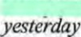
He was worried about this so I said to give him a phone before next week if he needs to talk about this again. Arranged to see Peter on Tuesday 9.11.93 at Burnside.
9.11.93
11.11.93 Meeting at Jamestown Nutseo to discuss Peter's CSVplacement. Everything going well. Possible Peter can extend his commitment to 3 days after his school leaving date. Spoke to Hugh Adam about this who participated in meeting.
17.11.93 Office visit - Peter came into see me and I gave him a lift round to his mother's.
22.11.93 Visit to Burnside - took Peter today to the Arm)' Careers Office in Dumbmton where we discussed the possiblities ofjoinmg up next year. The only option due to his lack of educational problems would be the general infantry. He has to return round about Eastertime if he is still has a commitment to this.
29.11.93 Office visit - general discussion with Peter about where he should go after Burnside. Not vety clear about this except he would like to stay in the Helensburgh area. Preferably a bed sit rather than supported lodgings. Talked to Peter about his review coming up and suggested he considered putting in his own report.
6.12.93 T/catl - Mary Buchanan to let me know Peter has been charged with breach of peace. This followed on/om an incident just outside Burnside over the
for Peter but we will now need to wait and see what happens next.
6.12.93 Office visit - saw Peter on his was to Discussed the breach of the peace charge. Peter not alot to say about this except he had been stupid. May well affect his chances ofjoining the Army.
7.12.93 Visit to Burnside - met with Peter and Hugh Adam, Key Worker and discussed the present situation. Also looked ahead to Review on 14th with regard to outstanding issued.
13.12.93 Office visit -
CIVVAR2
13.12.93 Office visit - spent some time with Peter going over his repott for tomorrows review. Said I would get this typed for him. Copy enclosed in file.
14.12.93 - decided today that Peter should continue at
For detail of discussion please see Minute enclosed in file.
Following Review I took Peter over to house where managed at last to see Discussed with her the possibility of Peter staying overat Christmas for 2 nights and then again at New Year, Family are quite happy for this to go ahead.
15.12.93 T/call - gnnke tn Irene Sommers at Burnside and explained about my home visit to and that everything was ok as discussed at Peter's Review.
23.12.93 T/call • spoke to Peter briefly just to confirm holiday arrangements. Also explained I would be on leave between 31.12.93 and 10.1.94. Agreed to phone Peter next week.
PETER NOBLE - |  | - 22.493.
29.12.93 T/call - spoke to Tommy Moreland - Peter was out. Asked Hugh Adam to ring me sometime 30.1293.

CNVAR2

10/01/94 | OV - Holiday arrangements went as Dlanned with Peter spending both weekends with an overnight at
12/01/94 | OV - Peter has appliedforjob at the base and also considering hotel work at Luss. Iris Vasile is his workerPom SAT who will be seeing him fortnightly. Supported lodgings in Helensburgh area would be Peter's /üst choice.
11/02/94 | OV - Peter has afternoon offfrom Nursery, going to girlfriends. No word about any of the jobs he has applied for.
14/02/94 | OV - Discussed possible weeks coupse with the Army at Penicuik. George Meiklejohn Ast Head Teaching Our Lady & St Pats rang me about this knowing Peter's interest in an Army Career. This may help Peter to reach a final decision. Keen on his name going forward.
24/02/94 | T/C - spoke to Robed Cowper careen office and confirmed Peter's name proposed for Army Coutse.
09/03/94 | Collected Peter at Burnside and went to Careers Office, He has been given a place on Army Coune week starting 11/04/94. He has to be collectedfrom Dumbarton at 9. OOam and I said I would get him at Burnside at 8.30am. Written details ofprogramme to be sent on.
16/03/94 | HV - Also meeting today at Jamestown Nutsery to look at Peter's placement. All very pleased with him and only change is that Peter will get half-day off to himself every week.
25/03/94 | HV - Brief contact at Burnside. Peter not vet" well - had a headache so plans for me to take him to Helensburgh were abandoned.
11/04/94 | HV - Collected Peter as arranged and took him to Dumbarton where he was picked up by Army stgfffor his weeks course.
21/04/94 | HV - Peter really enjoyed his week at Penicuik; he is awaiting a written assessment of his performance. He is saying he would like to pursue this as a career.
05/05/94 | HV - Peter has told his mother about next weeks review but doesn 't know if she intends to participate. Arrange lunch visit for Thursday 10th to over report.
09/05/94 | Meeting with Iris Visile to discuss progress.
CASE NOTES -
11.5.94 Child Care Review. Placement to continue but identify lodgings as soon as possible.
15.5.94 Home visit - Visit to Peter at Burnside, later dropped him off at his girlfriends.
24.5.94 Ojjice visit - Peter at office with his asking if I could send letter to Housing Department to help her get a house.
26.5.94 Letter to Housing Dept confirming Peter in care.
3.6.94 Home visit. Visit to Peter at Burnside. Discussion aboutfuture work now he has given up nursery. I shall go with him to Careen.
10.6.94 Home visit. Picked up Peter at Bumside and took him to see Robert Cowper at Vale Careets Office.
21.6.94 Home visit. Visit to Burnside. Peter is to go on holiday With Burnside stafffor most ofJuly so this will delay his applicationfor work.
23.6.94

11.9.94
29.7.94 Home visit - sat peter at Burnside and went over my SBR with him. He feels if he leaves care he would like his supervision to continue.
2.8.94 TC - Peter has started work with the District Council ET scheme, placed at
Rosslea Hall Hotel. Arranged to see him after work on Thursday,
4.8.94 TC - Peter called to cancel appt. He has to go straight to his girlfriends.
25.8.94 OV - meeting with Peter to discuss time he has missed ai work. Also explained my views about what should happen at children 's Hearing Peter appears vet)' uncenain about hisfuturejust now.
1.9.94 OV - meeting with Peter and Mary Buchanan unit manager at Bumside. Peter has now had one overnight stay at his suppotted lodgings. Agreed to move as soon as possible after the Panel to try and resolve travelling problems about work.
7.9.94 Children 's Hearing - supervision order varied to standing home supervision

Older. Peter will move to from 11.9.94,
12.9.94 Home visit - Saw Peter at house, he has moved successfully. Nov back working at Rosslea Hall Hotel.
20.9.94 OV. Picked up Peter from work and went for a coffee I shall go with him next week to meet the
CIVJBPN

- CASE NOTES
27.9.94 Peter called into after work - now placed at the Rosslea Hall Hotel and this seems to be suiting him better - less travelling. Confirmed Review at supported landlady 's next week.
6.10.94 Meeting at ;ypmted lodgings at Clynder. Everything is working to everyone satisfaction a Peter seems settled enough. Agreed to give Peter a run up to Dumbmton on Tuesday and get expenses for college attendance.
11.10.94 Collected Peter at Clyde St and took him to Dumbarton so he could get travelling expenses for college.
27.10.94 Home visit - it seems Peter is in some dispute with his employer over his hows of work at the Rosslea Hall Hotel. Peter's version of this does not match up with what the hotel is saying. Problem seems to centre mainly on his working at weekends and having days offduring the week to compensate. These two things don 't tally. Agreed to take Peter to Dumbarton tomorrow to try and sort this out.
28.10.94 Office visit - went With Peter to Dumbarton and had meeting with his boss. They are basically saying that Peter's employment will be terminated as there is a major discrepancy about the hours he lus supposed to have worked and what has actually happened. Sorted our with Peter how to go about getting DSS Hardship Allowance.
30.11.94 OV- infonned by Peter that he is going to move out of his supported lodgings in Clynåer. Now that he is not working, time is hanging on his hands and he is intending to move in with one of his friends over in Haldane. I have previously spoken to Peter about this as this has been on his mindfora week or two but he has now resolved to leave his supported lodgings despite the advice offered by myselfand Iris Vasile. According to Peter I can now reach him at Court, Haldane.
19.12.94 TC- ntanagedto catch Peter at Burnside Children's Home. Told him thadsonze money for him and asked him to call in sometimes during the holiday period. Apartfrom that everything okay.
1.3.1.95 OV - gave Peter $15 from Clyde Action. Discussed plans for the future mainly employment and what Peter intends to do. He hasfinally resolved not to join the Army. TCto Robert Cowper to make an apptfor Peterfor 25.1.95 when I Will go with him,
25.1.95 Home visit - picked up Peter in Haldane and took hint down to Careen Office in Vale to see Robert Cowper„ there cue prospects of Peter going onto a Apex 8 week course which will give him Ccveers Advice and help him to follow up on job opportunities. This is held locally in the Vale and is quite attractive to Peter in the sense that it offers him some more money again.
7.2.95 TC-spokein Haldane - he has now started with Apex. Arranged to see hint on 10¹.2.95.
10.2.95 Office visit - Peterfailed to appear.
17.2.95 Office visit - Peter has an interview next weekfor a newjoh at a day nursery in Dumbcuton. Talked to him about sonte of the issues that might arise here. He is quite hopeful that this Will prove successful given his past experience in Jamestown Nursery.

CASE NOTES -

7.3.95 TC-spoke to Peter at he is aware that his allocated a house in Rhu and he tells pne he plans to move back he'? and live with her. This should be happening soon, also informed by Peter that he has been successful in his job application in Dumbarton but has not got a starting date. Arranged to meet him on 9.3.95 at the Alexandria Careers Service.
22.3.95 HV - met Peter in the Haldane for discussion about his situation - still hoping to get a job with local nursery in Dumbarton.
30.3.95 Home visit - called to see Peter by arrangement at Cook Road, Haldane but got no response.
12.4.95 Home visit - collected Peter in the Haldane and spent some tinte discussing his work options. He is asking about maybe getting some help with clothing. According to Peter he definitely has got the job in Dumbarton Nursery but is not sure Of the starting date. Said [ would see about help with clothing.
25.4.95 Office visit - Peter called to see me because o%roblems with DSS and his Giro which we sorted out. Also asking about c thing money but told him I did not have an answeryet.
4.5.95 Office visit - Peter called to see me expecting to go and get clothing as he was aware that I had now received $150 from the District Officer, Child Care. Had to re-arrange visitfor tomorryvv as cheque is notyet cleared,
5.5.95 OV - took Peter to Clydebank Shopping Centre and bought him clothing with El50 from child care team. Clothing receipts in file. Peter tells me he is planning to move In with his mother at the house she has now obtained in Rhu.
10.5.95 HV - called to see Peter at Laggary Road, Rhu. It is his intention to stay with his mother during the week and spend weekends in Haldane. It now transpires he has not got thejob in the Dumbarton Nursery so he is once again lookingfor work.
11.5.95 Basically discussed with Peter plans for the future bearing in mind his supervision order will shortly be tenninated. Peter does not want to take up any of the local opportunities that are available via careen and given his decision not to join the Army it is difficult to see how we can progress this.
Asked him to think about these things and come back and see me next week to see if there were any further particular forms of action we Will follow through.
15.5.95 OV - further discussion with Peter along the previous lines - basically he does not want to pursue anything actively with careers just now and is certainly is not prepared to accept a YTS placement.
19.6.95 HV-norep1y.
21.6,95 HV- discussion with Peter and his mother about the situation. They seem to have reached an accommodation, whereby Peter can stay there during the week and go off to Haldane at the weekends. This seems to suit everyone concerned.
27.6.95 Called to see Peter to discuss with him the contents of my Panel report which has now been submittedfor his annual review.
CASE NOTES -
12.7.95 HV - explained to Peter I would be on holiday until the beginning of August and that his Panel was now scheduledfor 3.8.95. Told him to come into the office if he wanted help with transport.
3.8.95 Q!ildæn's Hearing - Supervision Order reviewed by the Panel and terminated.
9.8.95 Office visit - Peter seeking help With a DSS problem over his Giro. Sorted this out for him. Told him to keep in touch if any problems arise despite the terminated of his order.
CLOSING SUMMARY
Until September 1994 Peter was' in care at Burnside Children 's Home. Dischargedfrom care to Supported Lodgings but quickly left this and went to stay with Jriends in Haldane since May 1995 has been staying with his mother at her new council house in Rhu. Supervision Order terminated by Panel membens• in August due to Peter's impending 18th birthday. Basically over the 2 years I have known Peter he has proved difficult to engage in, in the sense that he is very much his own person and likes to make his decision about his life and keep some areas of his activities very much under wraps. This has always been an openly acknowledged aspect of our relationship. Peter is aware that he can approach the department at any time should he needfuture support.
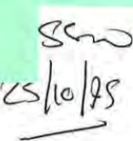

CASE FILE
01 Section 15 social Work (Scotland) Act 1968
02 Section 16 social work (Scotland) Act 1968
03 Section 37 Social Work (Scotland) Act 1968
04 Section 40 Social Work (Scotland) Act 1968
05 Section 44(1 Social Work (Scotland)
Act 1968 with Condition of Residence
06 Section 44( 1 Social Work (Scotland)
Act 1968 Home Supervision
07 Section 44(1 Social Work (Scotland)
Act 196B
08 Section 58(a) Social Work (Scotland) Act 1968
(as amended by HASSASSA Act
1983 Sec 814))
09 Section 42(3) social work (Scotland)
Act 1968
10 Section 43(4) social work (Scotland) Act 1968 | 666B
1 1 Section 1 Procedures
(Scotland) Act 1975 + 406
12 Section 323 Criminal Procedures
(Scotland) Act 1975
13 Section 206/413 Criminal Procedures
(Scotland) Act 1975
14 Section 12(5) Foster Children
(Scotland) Act 1984
15 Section 26(1 Adoption Act 1918
16 Section 10 Matrimonial Proceedings
(Children) Act 1958
17 Section 1 2 Matrimonial Proceedings
(Children) Act 1958
18 Section 7 Children Act 1958
19 Section 1 1 (1 Guardianship Act 1973
20 Section 24 Social Work (Scotland) Act 1968
UNIQUE NUMBER OF CHILD
DATE OF BIRTH
DATE OF TRANSACTION
DATE ADMITTED TO
PRESENT PERIOD OF CARE
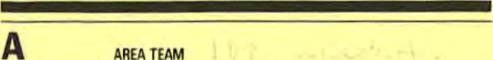
Social Work Department
AREA
TEAM
Council

Changes/Transfer Form
FOR CHILD IN CARE
NAME OF CHILO
B IS THIS CHANGEÄRANSFER? c
(Please tick appropriate box) REASON FOR CHANGE
[J A change of accommodation and 01 Decision of Hearing statute (Complete Sections O +E) 02 Decision of Court
C] A change of statute only C) 03 Planned Change (Complete Section E) 04 Breakdown
A change of accommodation only 05 Other (Please Specify) (Complete Section O)
C] A transfer to another area team. Name area team to which transferred.
21 Other (Please Specify)
PREVIOUS
Name
and
Address
- START PAYMENT TO: NAME OF FOSTER PARENT/ESTABUSHMENT.
(See Sect. D for address)
IF APPROPRIATE
- STOP PAYMENT TO: NAME OF FOSTER PARENT/ESTABLISHMENT.
(See Sect. D for address)
ANY SPECIAL INSTRUCTIONS
FOSTERING WITH RELATIVES | PREVIOUS | NEW
01 Temporary
02 permanent
03 Temporary
04 Permanen re adaptive
05 COMMUNITY PARENTS
06 Local Authority
07 Voluntary
08 LIST
09 SECURE ACCOMMODATION
10 LIST W
11 ASSESSMENT CENTRE
12 HOSPITAL
13 AT HOME
14 SUPPORTED LODGINGS. ILU, etc.
19 OTHER (PLEASE SPECIFY)
Designation
Area Office | Date
Countersigned | Admin
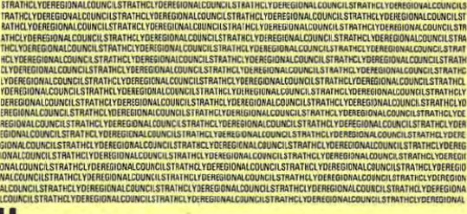

FOSTERING UNRELATED
CHILDREN'S HOME
u:otJBC1tS

H SIGNATURES
sw/csaaon.7,W1'Si

CASE FILE
01 Section 1 5 social work (Scotland) Act 1968
02 Section 1 6 social Work (Scotland) Act 1968
03 Section 37 social work (Scotland) Act 1968
04 Section 40 Social Work (Scotland) Act 1968
05 Section 44(1 Social Work (Scotland)
Act 1968 with Condition of Residence
06 Section 4411 Social Work (Scotland)
Act 1968 Home Supervision
07 Section 4411 11b) Social Work (Scotland)
Act 1968
08 Section 58(a) Social Work (Scotland) Act 1968
(as amended by HASSASSA Act
1983 sec 8(4))
09 Section 42(3) Social Work (Scotland)
Act 1968
10 Section 43(4) Social Work (Scotland) Act 1968
11 Section Procedures
(Scotland) Act 1975 + 406
12 Section 323 Criminal Procedures
(Scotland) Act 1975
13 Section 206/413 Criminal Procedures
(Scotland) Act 1975
14 Section 12(5) Foster Children
(Scotland) Act 1984
15 Section 26(1 Adoption Act 1978
16 Section 10 Matrimonial Proceedings
(Children) Act 1958
17 Section 12 Matrimonial Proceedings
(Children) Act 1958
18 Section 7 Children Act 1958
19 Section 11 (1 Guardianship Act 1973
20 Section 24 social work (Scotland) Act 1968
UNIQUE NUMBER OF CHILD
DATE OF BIRTH
DATE OF TRANSACTION
DATE ADMITTED TO
PRESENT PERIOD OF CARE
 | SEX |  | Male [3 Female


Social Work Department
Council

Changes/Transfer Form
FOR CHILD IN CARE
NAME OF CHILD
B IS THIS CHANGVTRANSFER?
(Please tick appropriate box)REASON FOR CHANGE
A change of accommodation and 01 Decision of Hearing statute (Complete Sections D +E) 02 Decision of Court A change of statute only 03 Planned Change (Complete Section E) 04 Breakdown
A change Of accommodation only 05 Other (Please Specify) (Complete Section D)
A transfer to another area team. Name area team to which transferred.
21 Other (Please Specify)
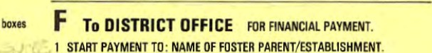
D ACCOMMODATION Please give Name and Address of
Placements and tick the PREVIOUS Name and Address
(See Sect. D for address)
IF APPROPRIATE
2 STOP PAYMENT TO : NAME OF FOSTER PARENT/ESTABLISHMENT.
NEW Name and Address
FOSTERING WITH RELATIVES | PREVIOUS | NEW
01 Temporary
02 Permanent
03 Temporary
04 Permanent/Pre adoptive
05 COMMUNITY PARENTS
06 Local Authority
07 Voluntary
08 LIST
09 SECURE ACCOMMODATION
10 LIST 'G'
11 ASSESSMENT CENTRE
12 HOSPITAL
13 AT HOME
14 SUPPORTED LODGINGS. ILO. etc
19 OTHER (PLEASE SPECIFY)
Designation
Area Office | Date
Countersigned | Admin
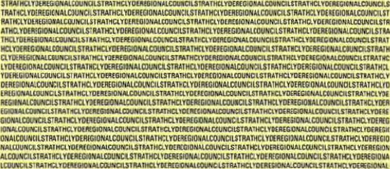
(See Sect. D for address)
ANY SPECIAL INSTRUCTIONS
FOSTERING UNRELATED
CHILDRENS HOME

H SIGNATURES
Signed
S*/üsuoco.1'Wn5t

NAME; Peter Noble
Ifeel that I have a good relationship with my social worker and my keyworker and that they are always their when I need them. lam glad that I got a CSV placement because it gives me something to took forward to, and hoping it will help me get a job when the placement is finished.
Burnside has done me a lot ofgood. It has helped me grow p and think for myself. Last week I got an application form for Faslane Base.to be a Mechanical Engineer, hopefully it will be a success. When I leave here I hope to get a bedsit in Helensburgh.
I. What I think about being in care
Being in Burnside has helped me settled down from my old u.gy - see myself Ästa_ying in Burnside for now.
2. Where should gQ next
Hopefully I would be able to stay in the Helensburgh or Rosneath area. I would like to stay in a bedsit to start with.
Name of Child: Peter Noble
Date of Birth:

18.11.77
Name of Home:
Burnside
Date of admission:

5.11.92
Summary Of decisions from last review (if appropriate):
- — Placement at Burnside to continue
- Proceed with Community Service Volunteers Scheme
- — Peter to look at ways of better using his free—time.

l. Legal Position/Section under which child is in care:
Section 44 (I) (b)
Any action indicated;
None

2. Current address/es of:
Parents:
2 Cedar View , Rosneath
- Siblings not in care:
- Siblings in care:

- Present situation with family since reception into care/last review;

Continued

- Date/s and nature of Social Worker's contact With child since reception into care/last review:
6.9.93, Office Visit 10.9.93, Office Visit 28.9.93, Home Visit 30.9.93, Office Visit
- 10.93, Office Visit. 26.10.93, Home Visit. 1.11.93, Office Visit. 11.11.93, Home Visit
17.11.93, Office Visit. 22.11.93, Home Visit. 29.11.93, Office Visit. 7.12.93, Home Visit.

- Date/s and nature of Social Worker's contact with family since reception into care/last review:
5.9.93, Office Visit. 1.11.93, Office Visit.

- Areas of Concern:

- Family Also Peter seem to be drawn into this as an "emotional" support and the emphasis of the relationship needs to change.
- Particular reference to child in care (including progress since reception into care/last review.)
Peter recently charged with Breach Of the Peace. This could adviseöly affect Peter's plans to join the Army.
Other
agencies
involved:
Community Service Volunteer 's

- Needs of the child (estimated length of placement, type Of placement, involvement oi other agencies, estimated nature of parental contact etc.):
Peter has now realised his official school leaving age and has to face decisions about the future . He has an interest in joining the Army but it is hard to say how serious this is. He prefers living at Burnside and for as long as he is in care, it is my view that he should remain there.

Continued
- Plans for child in view of above comment (including short, medium and long objectives):
What happens next depends on where Peter secures employment following hig spell with C.S.V.
Again depending on his mother's position i. e, if she got her own place there is no reason why Peter should not move in, especially if this was to be in the Helensburgh area.
9(a) Is an application for Assumption of Parental Rights appropriate? Yes/No

- Any further comments;
Tt is now clear that Peter is only prepared to share limiEed aspects of his life with Social Work staff. Largely, he tolerates is because he needs the practical resources that the Dept can Offer at an emotional level Deter prefers to be circumspec tual - I think we should recognise this and respect it.
Following Review referral to S.A. T. to look at possible resources in Helensburgh.

Il. Persons who will atttend review (from area team):
Jim Robb, Senior Social Worker
John Dryden, Social Worker
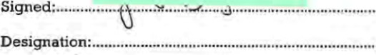
Date: .................„..m • •


Strathclyde
Regional Council
W3ag

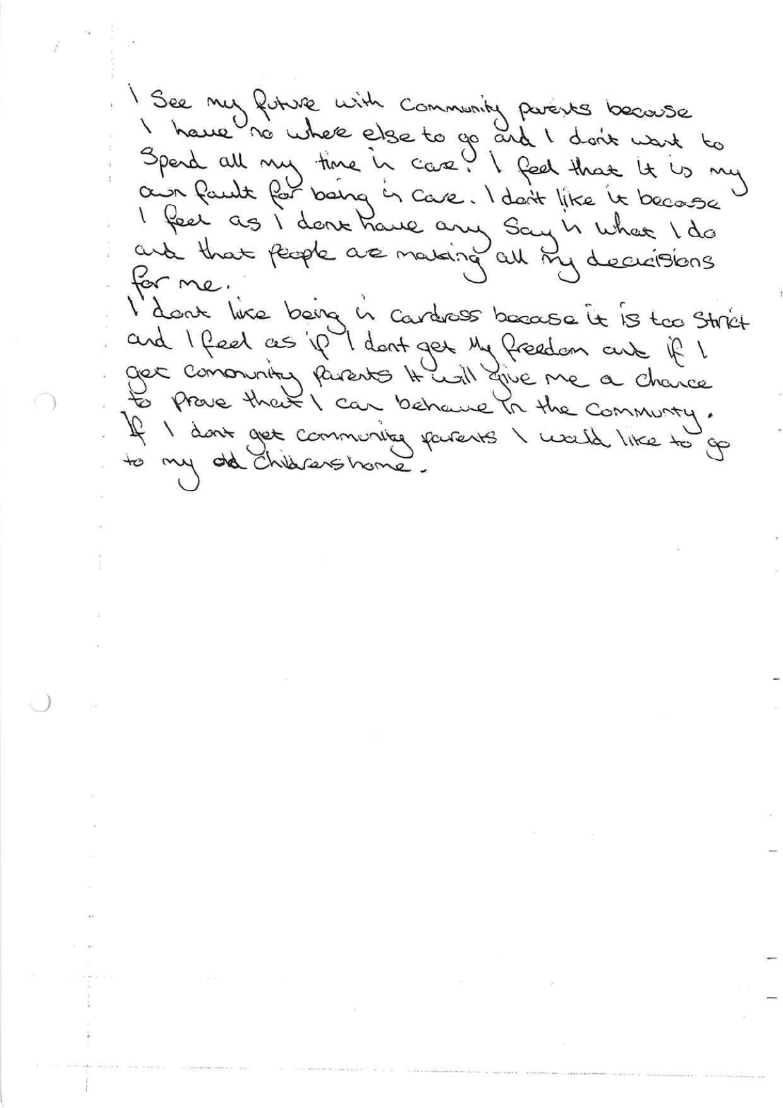

236 Clyde Street Glasgow Gl 4.JH
Telephone
041-204 1681
041-204 0668
CSV creates opportunities for peoplo to play an activo part in tho lifo of their community.
CSV IS a registered charity,
CSV

Plot(e for peöp(é
Peter Noble,
Burnside Children's Hone ,
13 Davidson Road,
Alexandria ,
Dunbartonshire
October 15, 1993
Dear Peter ,
I hope that you have enjoyed your first couple of days at Jamestown Nursery .
As we agreed, your days at the Nursery will be Thursdays and Fridays, from 9.30 a.m. till p.m. each day. Your duties will include:
preparing snacks helping with the clearing up playing games with the children accompanying children and staff on outings preparing materials doing some repairs and handywork assisting with some gardening
The first meeting to discuss your placement will be held at the Nursery on Thursday, I).th November, Qt p.m. However, please do not hesitate to contact me if you have' any problems or difficulties .
Best wishes ,
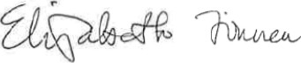
Ruth Milligan,
Organiser — Stratbclyde "Give and Take" Scheme

number 313352. It Is part of Community Sorv•ice Trust, a company limited by guarantee registered In England under number 1435877. Community
Service Trust Is itself a registered number 291222.
s: 53 F REDC .
REFERRAL FORM - CSV STRMffCLYDE GIVi' TARE

NOTE: Please ensure that a recent Soc{al Background/ Panel Report enclosed when returning thig form to:
Linda Small OR Ruth Milligan
(South Strathclyde) (North Strathelyde)
CSV, 236 Clyde Strpec, Glpegov, Gl 4jH
AND COPXES OF BOTH PORH.AND REPORT(s) TO:

DATE: 3.8.1993
NAME OP SOCIAL WORKER: John Bryden
OPPICE ADDRESS: 50/52 Sinclair Street Helensburgh
TEI,: 0436 73328
ANY INTERESTED PARTIES (e.g. Keyworker) :
Hugh. Adam, Burnside Childrens Home.

NAME OF YOUNG PERSON: Peter Noble
DATE OF  18.11.77. AGE: 15 years
ADDRESS: Burnside Childrens Home 13 Davidson Road
Alexandria
TED: 0389 53910
PARENTS ADDRESS 1? DIFFERENT PROK
Not ävailable presently
TEI,:
DID THIS YOUNG PERSON FIRST BECOME INVOLVED SOCIAL AND :
Known since February 1992 owing to breakdown in relationship at home with his mother and her cohabitee. Failure to attend school and one incident of theft by housebreaking. Period of assessment at cardross followed by placement November 1992 at Burnside Horne, Balloch where he has continued to reside
3 fil-lfi ' 33IJORK TO HELIPGH .
2/
3

PRESEN^{T}* StATUS 0? INVOLVEMENT SOCIAL WORK DEPAR'ÆiGi%:
44 44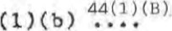Section 15
Section 16 Voluntary Supervision
(Please tick to Indieate the current Involvement Of the SVD)
HOW LONG SIAVB YOU KNOWN THIS YOUNG PERSON? :
I have only • recently taken over responsibility from another worker (June '93),
FAMILY BACKCROUND:
for a time In Hartlepool but returned to Kilcreggan with peter during 1988.
and Peter then returned for about six months to live with his father. This didn't work out and once again peter came back to Scotland.
SCHOOLS ATTENDED bND REASON FOR LEAVING (vich dates) :
Secondary schooling has been seriously disrupted owing to frequent moves. Peter gets nothirig from attending school and basically has just resolved not to go. His last "hool was Our Lady and St pat's, Dumberton, but he has not attended this year. it is unlikely Peter will go back to school for the four months which remain to his leaving date.
STANDARD OP LITERACY/iQiERåCY (If available, school reports would be 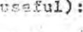
No school reports available. Peter has ability but has fallen behind obviously through the extent of his absence .

e AUG ' 33 8 : 54 WORK . 304

RESIDENTIAL EXPERIENCE AND REASON FOR R. l.c. (with dates) :
I feel I have aleardy covered this aspect.
PANEL INVOLVEMENT/POLICE RECORD:
(N. B : Please give as much detail as possible — ve operate a non—rejection policy)
Peter is the subject of a 44 (1) he has had one incident of offending which happened over a year ago.
PERSONALITY AND RELATIONSÆIPS:
Peter is confident and outgoing and can appear older than fifteen and his girlfriend is two years Older .
I have attached a copy of the Cardross assessment which gives more information on this 9spect.
SKILLS AND INTERESTS:
a AUG e: 54 SOC t AL WORK TO HBLIRGH 
NEGATIVE PACTORS (e.g. health problems):
None
WHAT OTHER OPTIONS HAVE YOU EXPLORED FOR THIS YOUNG PERSON (e.g. Community Industry)? :
Peter's aim is to join the Army whenever he is able. Other options not appropriate at this junction until he has left school,
WOULD THIs YOUNG PERSON BENEFIT FROM A PERIOD AS A COMMUNITY SERVICE VOLUNTEER?
Tt would give a sense of purpose and help Peter to extend his understanding of his own situation. It could help to identify new skills and build a more positive self—image

CHECK LIST
HAVE YOU:
Spoken to the young person about the referral?
- Filled in each eectlon as fully as possible?
- Enclosed a recent background report?
- Sent copies Of the referral Corm and baci'Ætound report ee the Liaison Officer for your ares (name at of form)?
- Retained your own copy OE the referral form and report?

236 Clyde Street Glasgow Gl 4JH
Telephone
041-204 1681 Fax
041-204 0668
V aeates tuniies for people to play an active part in the life Of their a)mrnunity.
CSV Is a registered charlM. number 313352. It is Of
Community Service Trust. a llmltod by guarmleo reglstered In England under number 1435877. Commun'ty
csv

SCOTLAND

Peotte for peQ(e
Peter Noble ,
Burnside Children's Home ,
13 Davidson Road,
Alexandria ,
Dunbartonshire
October 17, 1993
Dear Peter ,
I have developed a placement for you at Jamestown Nursery School, Main Street, Jamestown (tel: 57729) . I hope that you will enjoy this placement and I know that the staff are certainly looking forward to having you there .
I've arranged for you to start at the Nursery on Thursday 14th October . I '11 collect you from Burnside at I p.m. amd take you across to the Nursery.
I hope that these arrangements are suitable for you.
Best wishes , ech.
Ruth Milligan ,
Organiser — Strathclyde "Give and Taken Scheme.


Sorvlco Trust Is itwlf a registered e-,ahty, number 291222.

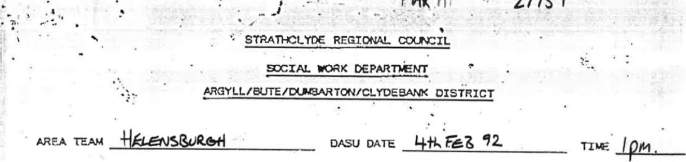
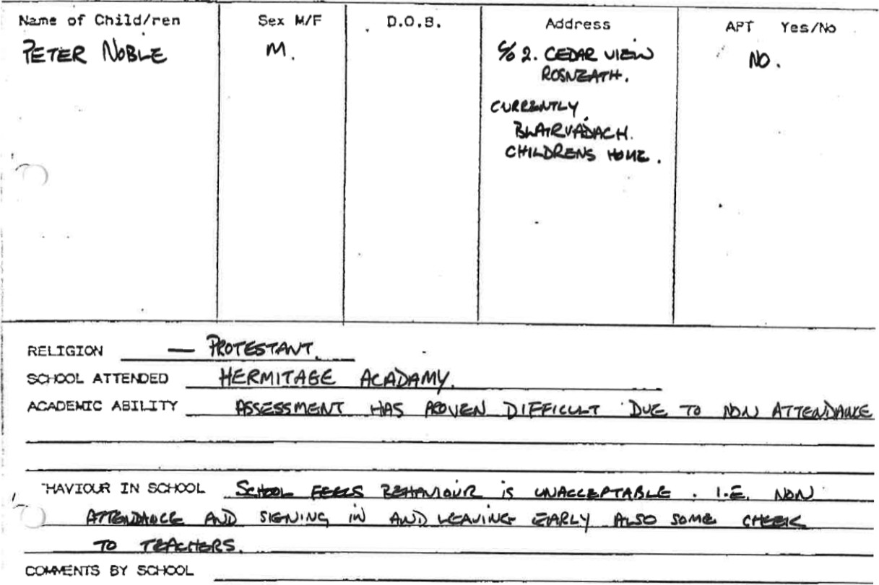

CHILD •s LEGAL STATLS:
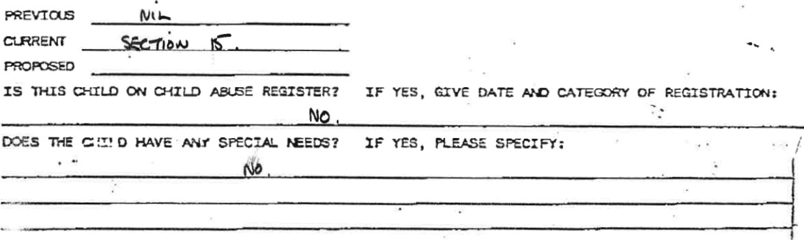

  Parents | Age   |   Mdress | 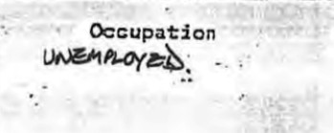
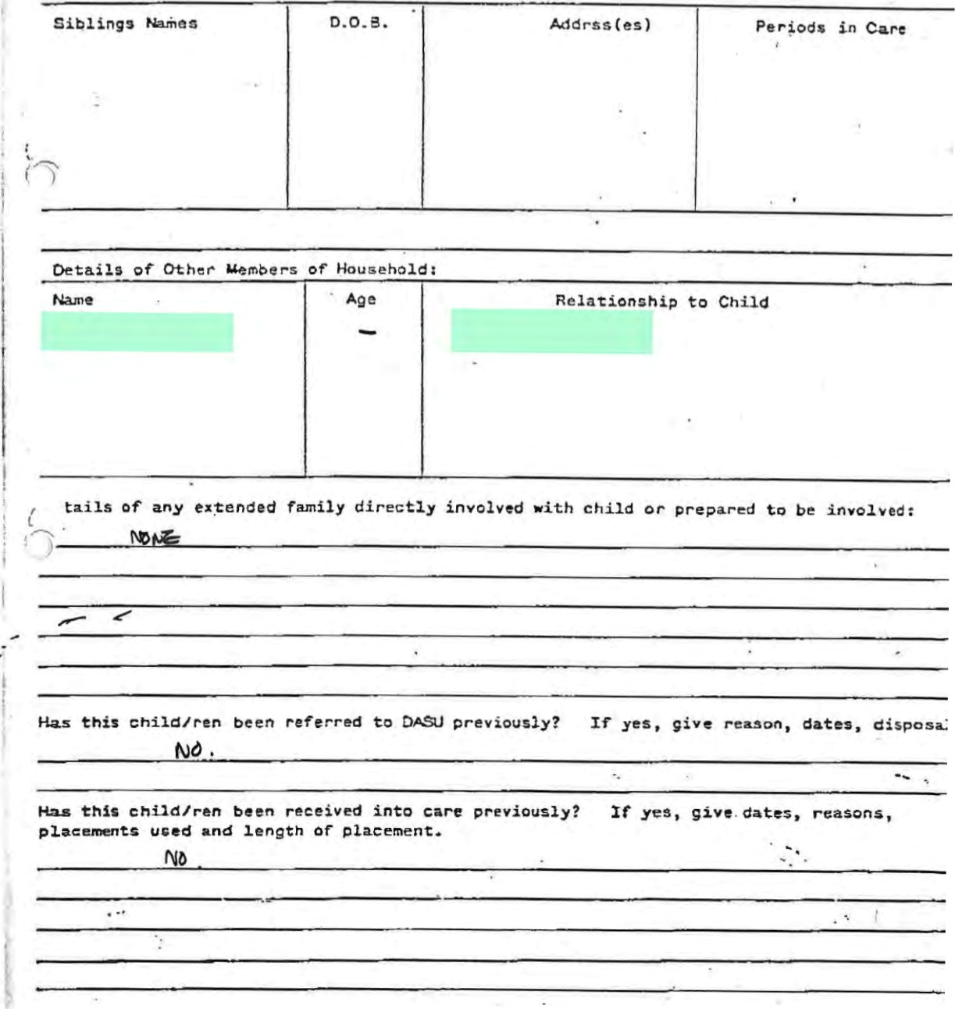
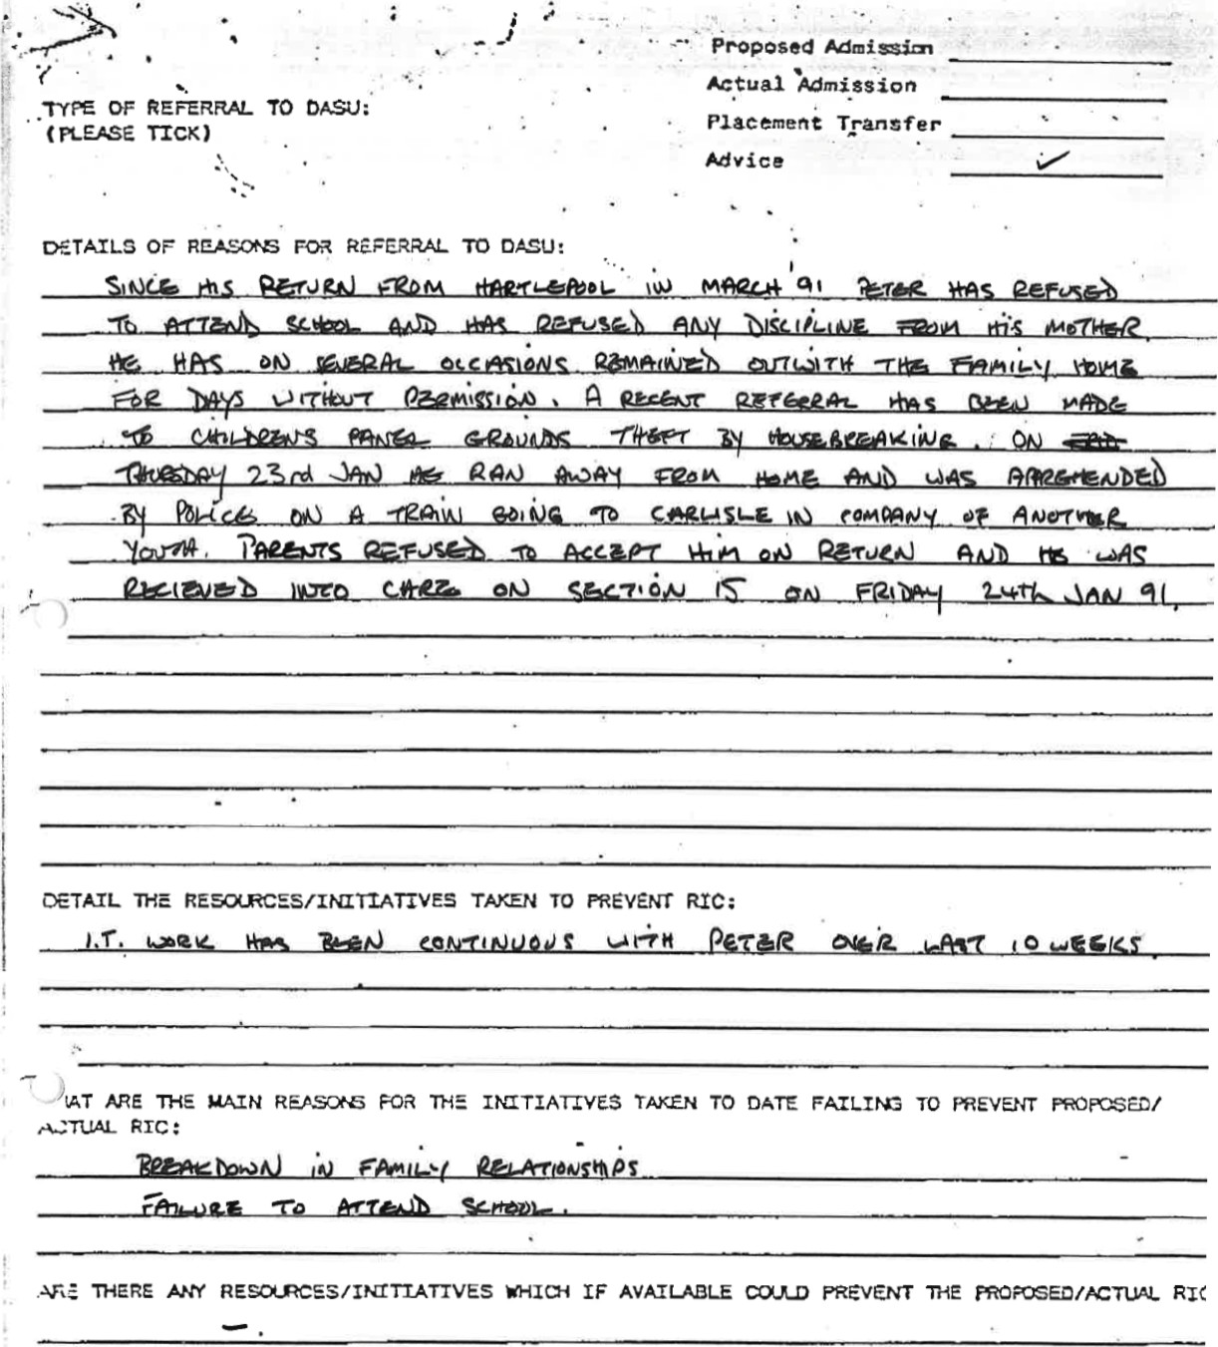

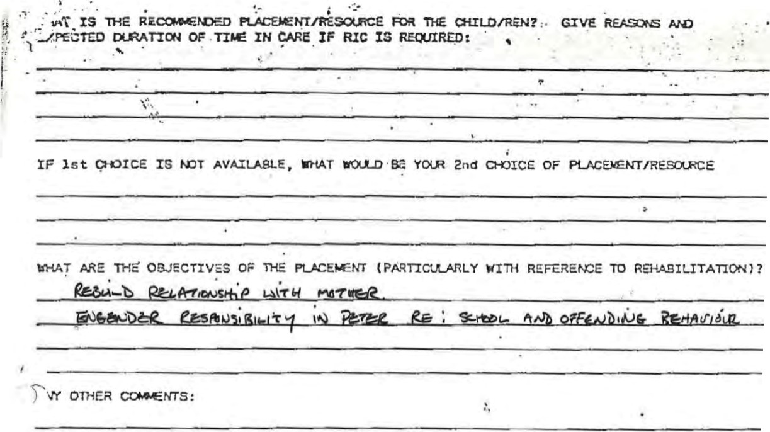


SOCIAL YORKEROATES"
SEMIOR SOCIAL YORKERDATE
na.su


M E M O R A N D U M
Tel : (0389) 2770T Our Ref:
Your Ref: Strathclyde
Date: 30 April 1993 SCOTLAND
A nuclear• free zone From: Mr J McLean authority
District Officer (Child Care) An equal
Argyll/Bute/Dumbarton/C1ydebank District opportunitiesauthority
To: | Ian Newall  Area Manager  Helensburgh
SUBJECT : | DISTRICT ADMISSIONS SUPPORT UNIT: 27 APRIL 1993
CHILD : | Peter Noble D.O.B.: 18/11/77
ADDRESS : | c/o Burnside
MEMBERSHIP OF DASU: John McLean, Derek Bannon, Bill Jardine , Robbie Warner, Alice King
CHAIRMAN: John McLean
SUMMARY OF DISCUSSION
Case presented by Joe Docherty.
Peter's placement at Burnside has broken down, as has his attendance at mainstream school. Following an incident at Burnside when Peter was found in possession of Cannabis Resin, which, he was openly smoking, a Child Care Review (31/3/93) agreed to investigate a residential school placement, with a preference for Geilsland, as he require preparation for independent living.
Social worker indicated that while Ln Cardross Park, the decision to place in small childrens home was considered appropriate given Peter 's comitment at that time. However, since admission to Burnside Peter's school attendance fell to and the situation within the home became problematic with very little time spent there. Concern has been expressed about Peter's involvement in the drug scene locally, and also that he is involving other residents. was noted that Peter's relationship with other residents is viewed as being very influential.
MSWDDB412/KH/d
In acknowledging Peter's lack of commi tment to placement in Burnside, a residential school placement was considered appropriate this time, with a preference for placement within Geilsland.
FURTHER ACTION REQUIRED: BY WHOM TIMESCALE
DECISIONS:
Agree investigation of residential school placement (Geilsland) .
2. Social worker to liaise with Derek Bannon, ADO Child Care re above.
COt01ENTS:
DASU 2: (I ) Please advise me should there be any particular difficulty in taking this action.
(2) Area Managers, please complete and detach.

To: District Officer (Child Care) DATE :
Argyll/Bute/Dumbarton/CIydebank District
CHILD : Peter Noble DOB: 18/1 1/77
ADDRESS : c/o Burnside
I have to advise you that the recomrnendations made at the DASU meeting on
- have been implemented on
- have not been implemented — reasons:
DASU 2(a) Signed :
MSWDDB412/KH/d
DUMBARTON VEST INIERHEDIATE TREATMENT TEAH

IT WORKERS REVIEW REPORT
NNE: Peter Noble
REASONS FOR REFERRAL TO GROUPWORK:
Initial referral to the groupwork prograrrne outlined the follovring areas as the main difficulties for Peter:
I. History of truancy.
- Difficulty in making friends, involved in bullying, being bullied at school.
- Involved in offending — vandalism.
Since referral other areas identified:
  - Previous experiences with family, Current relationships at home with run and
  - Involvement in theft in local corrrmanity.
NATURE OF CROUP ATTENDED:
13 — 14 year old boys. Prograrrrne looked at following issues:
- School Issues (truancy and behaviour)
- Role of boys (pressure of boys to be tough, good fighters, gang members)
- Bullying
- Peer group Pressure
- Friends and Relationships
- Dealing with rules at home and at school
DURATION:
12 week prograrrrre (3 sessions were outings)
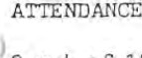DETAILS:
- 9 out of 12 sessions,
MAIN BODY OF REPORT ( TO INCLUDE YOUNG PERSON'S UNDERSTANDING MD :
TO GROUP OBJECTIVES, RESPONSE '10 DIFFERENT ELEHEN'IS OF GROUP, EEHAVIOUR, VALLE TO GROUP, RELATIONSHIP WITH GROUP HEMEERS AND WORKERS, ACHIEVEHENE AND QUISTANDING DIFFICULTIES)
ATTENDANCE
Peter attended 9 out of 12 sessions. A couple of sessions he missed vhen the situation at school deteriorated and peter was suspended and also began truanting from school.
- PETER WBLE (Continued)
IN GROUP
Peter related well to rnost members of group, although the main difficulty for Peter was the fact that the majority of the group were less mature than him and he became annoyed and frustrated by their 'carry on' and silly disruptive behaviour.
In the group, particularly towards the end of the progranne, when the situation was deteriorating at home and he was received into care. Peter appeared depressed, fed up and less motivated in group.
Peter participated well in work sessions and showed most interest on the topic of 'Bullying' . However, the make—up of the group meant that at times, issues were not di$cussed on the 'more mature' and appropriate level for Peter. Feeling of group workers was that Peter would have benefited from a slightly older age group.
In group, Peter presented no behaviour difficulties.
CONCLUSION
During groupwork prograrrrne, Peter's situation deteriorated in both school and at home. He was suspended from school and received into care and placed at 'Blairvadach' .
When Peter was first referred to the group there was little social work involvement. Peter's attendance at group provided opportunity to get a cleared picture of his main difficulties and to offer him weekly, regular support. PeTör would use this support to sane extent and would talk openly and a lot v•hen being driven home by workers.
Workers felt that Peter would have gained more from groupwork programne if the group members had been slightly older.
MAIN DIFFICULTIES FOR PETER
- School Situation (truancy and involvement in bullying)
- Association with gangs' in Helensburgh. Involved in offending behaviour.
- Confusion and difficulty Mith family history and experience and current family situation (mun and new co—hab) .
CONCLUSION
When the group ended, Peter was in care under Section 15, at 'Blairvadach' . A Care Plan for Peter was in the process of being drawn up, Depending on whether peter remains in care or returns horre , participation in I.T. Groupwork Progranrne may be appropriate again.
Feeling of group workers was that peter would benefit fran a slightly older age
Argyll +Bute
COUNCIL
Argyll and Bute Council
Comhairle Earra Ghåidheal agus BbÖid

MEMO

SOCIAL WORK DEPARTMENT
Date: | 13 MAY 1999 | Extension: | 8779
To: | JIM ROBB, SERVICE MANGER | Your Ref:
From: | JOHN BRYDEN, SERVICE OFFICER | Our Ref:

SUBJECT: PETER NOBLE (DOB 18/11/77) - 10/6 ROY YOUNG AVENUE. HALDANE
I have now met with Peter and his S.A T. worker Pat Taylor. He is seeking direct cash assistance and his position is as follows:
During April Peter was allocated a 3 apartment council flat with a weekly rent of E36.OO which he must pay in full, He has partly furnished this, ie carpets, fridge/freezer, some curtains, but still lacks many basic essentials, In particular he is looking for help with the purchase of a bed, cooker, curtains and essential household equipment
Peter is working under the 'new deal' programme as a landscape gardener, earning a net of ÆIOO per week. Beyond his rent and council tax, he has no fixed weekly commitments, but does help to support his baby daughter who lives with her mother at an address nearby. His capacity to purchase major items himself, therefore, is very limited,
Peter's casefile in this office was closed during August 1995, just before his eighteenth birthday. After his discharge from Burnside Children's Home (September 1994), he lived for a time in 'supported lodgings' but left these of his own volition to move in with his mother in Rhu at a house this Department was active in securing for her. Appropriate help was provided to Peter, therefore, after he left care until such point as he felt this was no longer requirec[
I have explained to Peter the relevant parts of the Children's Act, and he understands that he has no automatic entitlement to cash assistance and that any award would be a discretionary one on your part. He does not feel he needs practical support beyond What he is receiving from the S.A. T. in West
Dunbartonshire, but would accept a social worker being identified to oversee the use of any sum of money paid to him. No figure has been identified by anyone, but the items mentioned, plus a contribution towards household insurance and a TV licence would work out to about 500 / $600 at least. I have told Pat Taylor that I will discuss this with you and get in touch with her as soon as possible.

JohYBryden
M.IBNOBLE - GD
Strathclyde Regional Council
Social Work Department
Supported Accommodation Team
McLean Place,
Dumbarton,
G82 1 PY
Director: Miss Mary C Hartnoll, CBE, BA
Telephone No: 0389 763437/761626 Our Ref: IV/JS
Your Ret:
Date: 30 September 1994
If calling or phoning please ask iris Vasile
Mary Buchanan, Unit Manager,
Burnside, 13 Davidson Road,
Jamestown,
Alexandria
Dear Mary peter Noble (dob 18 November 19.77)

Further to previous telephone calls, I confirm that Peter's suppor • placement address is as follows:-
Armadale House, Shore Road, Clynder.
The telephone number is 0436 831336
I trust that this will enable you to update your records but please do not hesitate to contact me if I can be of further assistance.
Yours sincerely,

Iris Vasile
Support Worker
c.c.
LTRIVMB

