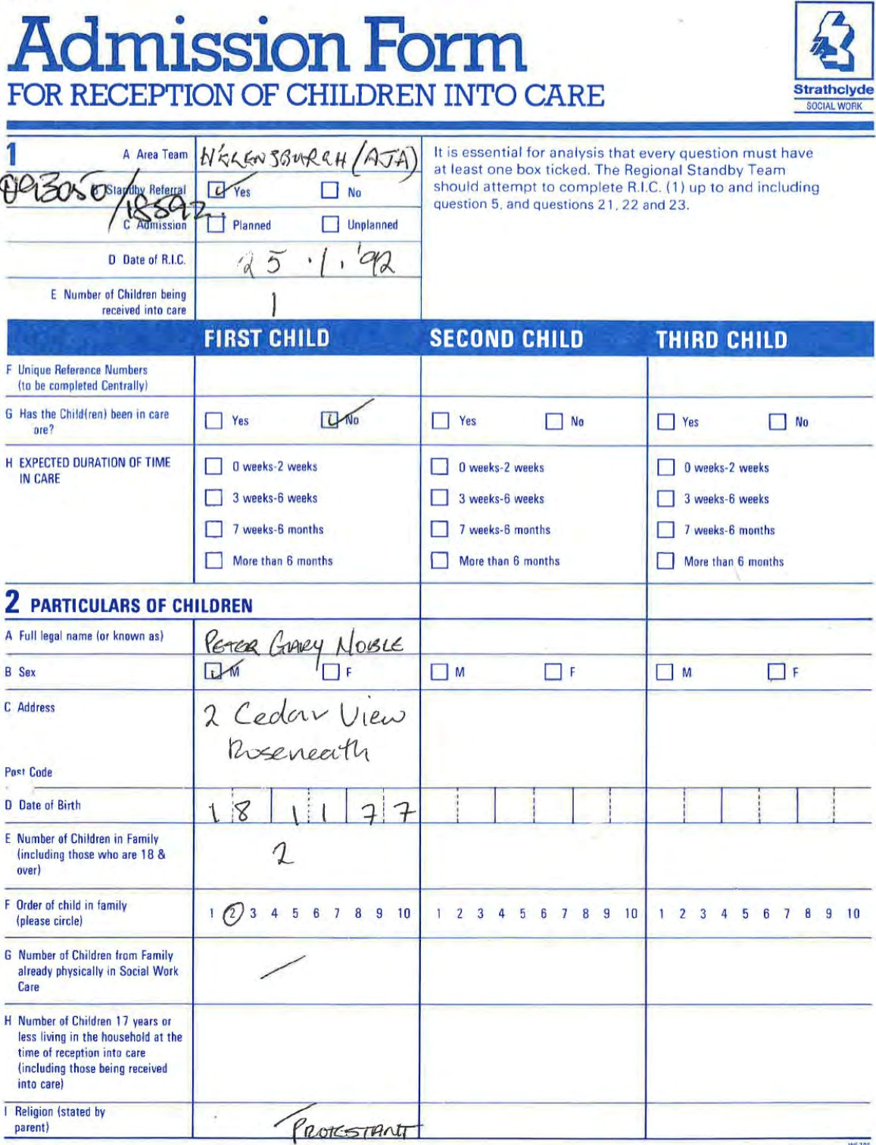
ws'gs
RIC
1.
CASE
FILE

3 PRESENT RECEPTION INTO CARE
(On'y one Main Reason and one Underlying Reason)

PLEASE TICK | Main Reason | Underlying Reason | Main Reason | Underlying Reason | Main Reason | Underlying Reason
PHYSICAL ILLNESS
- Female caret
- Male care'
- Both
MENTAL DISORDER
- Female caret
- Male care' 06 Both
DI PREGNANCY
DESERTION ABANDONMENT
08 Female cater 09 Male caret
10 Both
DEATH OF CARER
Female caret
12 Male caret
1 3 Buth
QREAKOOWN OF MARITAL ,CLATIONSHIP
1 5 PARENT PLACING CHILD FDR ADOPTION
1 7 MEMBER OF SAME
HOUSEHOLD AS PERSON WHO
HAS COMMITTED SCHEO
1 /CHILO ABUSE OFFENCES
37 SEC Female
Incest SW Act 1 968
LACK OF PARENTAL CARE

38 FALLING INIO BAD
ASSOC/MORAt DANGER
- MISUSE VOLATILE
SUBSTANCE
- NON ATTENDANCE AT SCHOOL
- CHILD HAS COMMITTED
OFFENCE
- OUTWITH PARENTAL CONTROL
IMPRISONMENT OF
- Female care' r Male caret 20 00th
DETERIORATING RELATIONSHIP
BETWEEN CHILD AND
- Female caret
- Male
- Both
INCAPABLE OF PROVIDING CARE
DUE TO DRUNKENNESS
- Female caret 30 Male caret
- Both
FINANCIAL PROBLEM OF
- Female cater 33 Male caret
- Both
- HOMELESSNESS
39 PART 5 TRANSFERS SEC.
3201) S.W.(S) ACT 68 36 OTHERS SPECIFY
Additional
Comments,

4 LEGISLATION
(Which Section(s) of Legislation are applicable in this case)?
The following legislation relates to an children who have been physicany sqarated from caters.

Main Subsidiary Main Subsidiary Main Subsidiary
Section IS Social Work (Scorl•ndt ACI 1968
Sot.al Watk
'Sonant/ Atl 1968
3 Section Walk
Act 1968
Section CO Social Work
(Scotland) Act 968
- Sect'0n
Act 1968 with
Cord'l•on of Residence
- Sect•on soc"' Work
Act 1968
Home Supervision
(Scotland) Act 1968
08 Seclicn WOL
'as amended b/ HASSASSA Act 1983 sec 09
/ScOtlandl Act
Sec "on Social Work (Scotland' '988
Cnninal procedu'es ISc01"nd)
Act • 406
Section 323 Clivmni
Act
13
1975
Section 12 Children
'Scotl•nd) Act 1984
- Fion Adoption Act
- Section
proceedings (Children)
Secuan Metnmcnia/
Act 1958
- Section Children
1958
- Section Guardimsåip
1913
- Section 24 Work
(Scotland} Act 1968
21

5 PRESENT PLACEMENTS

Name & Address Of Placement
Recommended Actual Recommended Actual Recommended Actual
FOSTERING WITH RELATIVES
- Temporary
- Permanent
FOSTERING UNRELATED
- Temporary
- Permanent/Pre adnptive 05 COMMUNITY PARENTS
CHILDREN'S HOME
- Local Authority
- Voluntary
- LIST 'D'
- SECURE ACCOMMODATION

10 LIST 'G' 11 ASSESSMENT CENTRE
- HOSPITAL
- AT HOME
- SUPPORTED LODGINGS.
19 OTHER (PLEASE SPECIFY)

6 FIRST MAIN REVIEW DATE
(Must be within 4 weeks Of date of reception)
Review Date
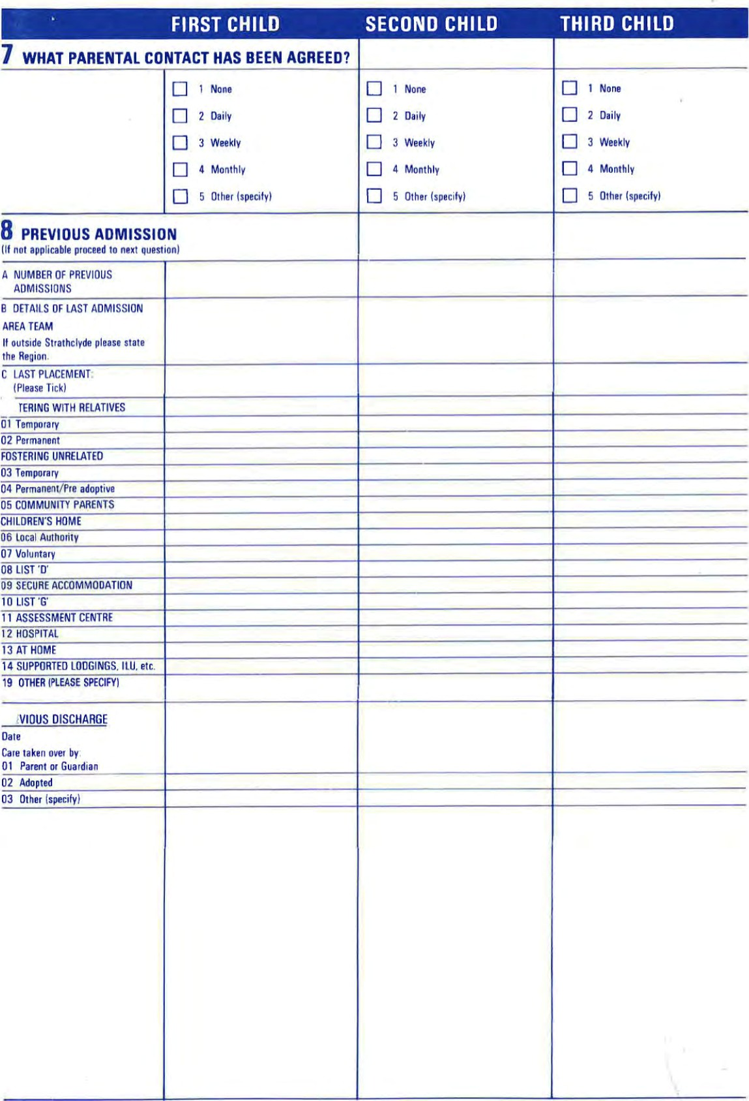

10 HOUSEHOLD PARTICULARS
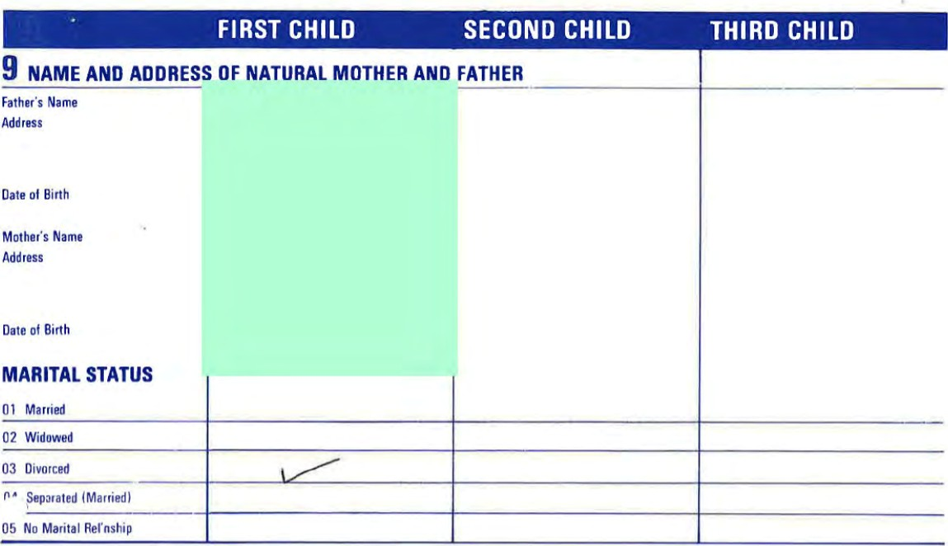
Enter the number and type of adults staying in same household as child(renj
Type Tvpe Type
 |  |  | Please Tic | (Please Tick) |  |  |  | (Please Tick)
01 | Natural Mother |  |  |  | NUMBER |  | NUMBER |  | NUMBER
02 | Natural Father |  |  |  | NUMBER |  | NUMBER |  | NUMBER
03 | Stepmother |  |  |  | NUMBER |  | NUMBER |  | NUMBER
04 | Stepfather |  |  |  | NUMBER |  | NUMBER |  | NUMBER
05 | female cohabitee
06 | Male cohabitee
07 | Grandmother
08 | Grandfather
09 | Aunt
10 | Uncle
1 1 | Sister
12 | Brother
 | None
 | Jther (specify)
15 | NIK
Male Caret (If different from Natural
Father) Name
RELATIONSHIP TO CHILD
Date Of Birth
Female Caret (if different from Natural Mother)
Name
RELATIONSHIP TO CHILD
Oate of Birth

1  to |  |  |  |  |  |  |  | FIRST |  | CHILD |  |  |  |  |  |  |  |  | SECOND |  | CHILD |  |  | THIRD | CHILD
1 CONTACT WITH RELATIVES
(Have any of the relatives and friends been visited with a view to caring for the child(ren)?)
 |  | Relatives Contacted  Names. Addresses and Relationship  Chiidfren) must be stated |  |  |  |  |  | No  if not, reasons must be clearly stated |  |  |  |  |  |  |  |  |  |  | C] Yes  If not. reasons must be clearly stated. |  |  |  |  | C] Yes  If not. reasons must be cleariy Stated,
 |  |  |  |  |  |  | FIRST |  | CHILD |  |  |  |  |  |  |  |  | SECOND |  | CHILD |  | THIRD CHILD

12 NAMES AND ADDRESSES OF FAMILY
(If not stated, in Section Il, detail all names and addresses Of family, This must be completed by the review date 'f not. reasons must be specified),
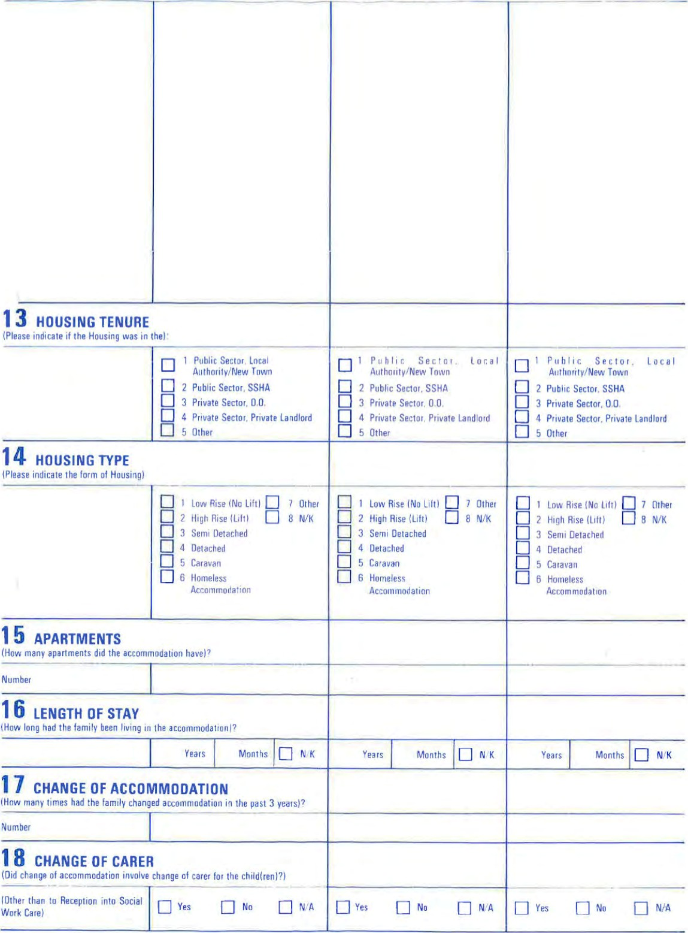
Public Sector. Inca' 1 Pilhlic Sect C'. local P u h lic Sector. local
Authority/New Town Auth01itv/New Town Auth0'ity/New Town
Public sector, SSHA 2 Public Sector. SSHA C] 2 Public sector SSHA Private Sector. 0.0. 3 Private Sector, 0.0, C] 3 Private Sector. 0.0.
- Private Sector. Private Landlord 4 Private Sector. Private Landlord 4 Private Sector. Private Landlord
- Other 5 Other
FIRST CHILD SECOND CHILD THIRD CHILD

19 EMPLOYMENT SITUATION
(What was the employment situation of the caret(s) when the child(ren) were received into care)?
Male Female Male
- Fug Time Education/Training
- Employed Full Time
- Self Employed
- Employed Part Time 05 Retired
- M.S.C. Employee
- Registered Unemployed 1 months
- Registered Unemployed 12 months and Over
- Unregistered Unemployed Incl. Housewife
- Other
1 1 Not Known

20 SOURCE OF INCOME
(Indicate if the caret(s) are in receipt of any of the followinq at the time of reception into care)
Main Form Maln
Secondary
of Income of Income
- Income from work
- Unemployment Benefit
- Supplementary Benefit
- Non Contributory Invalidity
Benefit
- Sickness & Invalidity Benefit,
Industrial Benefit
- Widows Pension
Family Income Supplement
- Grant
- Retirement Pension
- Unified Housing Benefit
13 Maintenance
Other (Specify)
12 None

21 FOR SECTION 15 ONLY 22 FOR ALL CHILDREN
Female Male Female
Main Form
Secondary Secondary
of Income
23 FOR SOCIAL WORK USE

Where appropriate
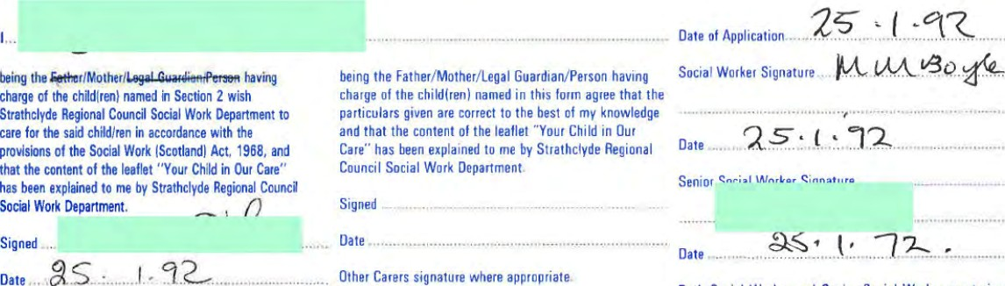
Date
Both Social Worker and Senior Social Worker must Sign
(Father/Mother/Legal Guardian/Person having charge of Signedthis form.
the child named in
Section 2), Date
Other carets signature where appropriate.
Signed
Date
F rom : Major E A Boyd MBE RE
LIAISON STAFF SCOTLAND
SCHOOLS LIAISON OFFICER (WEST SCOTLAND)
Charlotte House, 78 Queen Street, Gl asgow, GI 3DN
Telephone Glasgow Military: Ext 5739
Civil: 041-221-9955 Ext 26

Your reference
Head of Work Experience Our reference
ASLO(W) 27
Date
WORK EXPERIENCE SCHEME
COURSES - 1994
At set times throughout the year, the Army in Scotland runs one week residential courses to give pupils experience of Army life. These Army Familiarisation Courses are run in accordance with the Education (Work Experience) Act 1973 and comply with the principles and criteria laid down by the Scottish Education Department.
AIMS
The aims of these courses are
- TO introduce boys and girls to the Army way of life and give them the opportunity to gain practical experience Of the tasks and skills Of the modern soldier.
- To improve their general education by giving them some experience of community living and the need for self discipline.
LOCAMON /DURATION.
The courses will be based at The Army Training Regiment, Glencorse, near Penicuik, Midlothian. The duration of the course is 5 days (pick—up from school on Monday am and return to school Friday pm) .
COURSE DATES 1994.
During 1994, we intend to run seven courses on the following dates:
a. Course No 1/94 — From 11th to 15th April 1994.
Course No 2/94 — From 2nd to 6th May 1994.
- Course No 3/94 — From 23rd to 27th May 1994.
- Course 4/94 - From 13th to 17th June 1994.
Course No 5/94 - From 20th to 24th June 1994.
f. Course No 6/94 - From 12th to 16 September 1994.
Course No 7/94 - From 19th to 23 September 1994.

The 4 Army Schools Liaison Officers in Scotland, have each been allocated 12 places (10 boys and 2 girls), for each course.
They are responsible for the allocation of vacancies to schools in their respective areas . Vacancies will be allocated on a "first come first served" basis, but schools are asked, please, to limit their numbers to under 4. You are asked to remember the ratio of girls to boys!
SELECTION .
Pupils should be between the ages of 15—16 years, of good character, reasonably fit and likely to be acceptable, should they subsequently apply to enlist into the service.
BPPLICATION.
Careers staff or Work Experience Co—ordinators should apply in writing to the above address. giving the age and sex of the pupils named, and the course number and dates Of the preferred (or al ternative) course.
OF VACANCIP$.
ASLO West Scotland will confirm acceptance of vacancies by return, and issue full briefing instructions well in advance of course dates.
With kind regards.
Yours sincerely
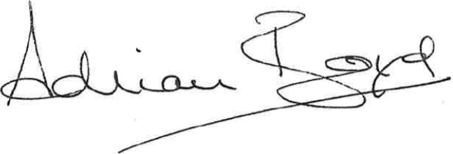

z)

Director: F E Edwards RD BA MUrUv FBIM
Cardross Park Child Resource Cenüe
Main Road
Cardross
Durnbarton 082 SEX
Social Worker
Snr Social Worker DO Child Care
Hermitage Academy
Peter McCann
Blairvadach CH
IT Project
Dear Sir / Madam

oratncayae
Regional
Council
A nuclear-free zone authority
An equal opportunities authority
Tel Cardross 841031 Our ref
Your ref
If phoning or Mr Robinson
calling ask for
Date 12 March 1992

Re : PETER NOBLE (DOB 18 11 77)
You are invited to attend the assessment / conference on the above child to be held at Cardross Park Child Resource Centre on the date and time stated below.
Wednesday 25 March 1992 at 11.00 am
Conferences are timed around our school hours to enable staff to be able to attend while free from supervising responsibilities . It is therefore important that every effort is made to be punctual. It is also Important as there is normally more than one conference scheduled on any given day.
Please contact me if the time arranged presents any difficulties
Yours sincerely
DUNCAN ROBINSON
ASSISTANT OFFICER IN CHARGE

Details of child needing family placement
Part I Please read notes for guidance before filling in the form

Agency details Name of agency
Helensburgh Area Team
Name of child's soctal worker Name of senior social worker/team leader
Joseph Docherty David Burke
Area address 50 — 52 Sinclair Street Tel. no: 0436 73328
Helensburgh Name Of link worker for inter-agency placement
Tel. no: 0436 7332B Tel. no:
Updated Updated

Child concerned Name Date ot birth
Peter Noble 18.11.77.
Preser)t address c/o Cardross Park Child Resource Centre
Tel. no:

Name(s) of key person(s) caring for the child there, i.e. foster parent, key residenttal worker
Ann Gillespie

  Type of placement needed (see also section J I, page 6) For how many children is placement required? Age(s) 14 | Gender(s) | Male
Placement for: adoption fostering with aim of
(1) adoption
long-term fostering fostering with aim of Other (specify) rehabilitatiOO
Are there any expected legal complications If so, specify which would affect the choice of family? No
Special placement considerations 'please .ndicate which are essenuai requirements and which are preferences, You should .ndicale in part 'i reasons for the importance of these requirementsl-
J. Ethnic 4. Medical
- Religious 5. Educational
- Geographical

Family Structure Add anything you can about the Sort ct family W'th whom you think the child woule do best

The child First names Surname
Peter Gary Noble
see note a Gender Known as: (include nicknames) Date of birth
Male Peter 18.11.77.
• Marital extra-marital non-marital adopted Place ot birth Kilcreggan, Scotland
AA b
British/Scotti sh None
Give details of baptism. confirmation or equivalent ceremonies Whet religion. does the child pracose?
c Legal Status Brief comments care

44 (1) (b)

If your agency supervises the child on behalf of Has this agency another agency state which agency has legal agreed to the responsibility for the child. proposed plan for the child?
• Yes/No
Has the child any rights/claims under the Fatal Accidents Act 1976 sec 30 or any other nghts to or interest jn property? ves please specify,


Brief description of child
Peter is a tall well built youth and presents as much older than his 14 years. He is in general pleasant and mature in his dealings with adults, but can be truculent and sullen when faced with difficulties. He can appear to be interested and communicative when discussing problems but often finds it difficult to follow through advice.


Health
Peter has had no significant health problems over recent years Hie mother states that he was diagnosed Hyper—active as a child.

Education Name of present school
Cardross Chi Id •Resource Centre
Address of school Cardross Park, Main Road, Cardross

see note g 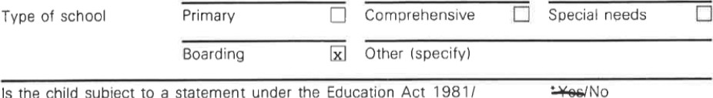Is the child subject to a statement under the Education Act 1981/ record of needs under the Education (Scotland) Act 1981 ?

List schools previously attended:
Name Address | Type Date Attainments
Hermi tage Academy Craigendoran Helensburgh | Comprehensive
Beirton Comprehensive Rift House Estate Brierton Lane  Catcoat Road  Hartlepool | 1990
Moroton Comp Carlisle | 1990
Kilcreggan Primary  John Logie Baird | 1988
Primary | 1983


Child's placements since birth
List detaiis of all known moves since birth including present placement. At the end of the list give brief comments/observations about the quality of care the child has received, reasons for moves etc.
h Age of child Dates of Types of placement Names of principal at placement placement e.g. at home/foster home/ carer(s) e.g. foster Total (months/years) (month!year) residential mother, key worker duration
Born 18.11.77 - May '78 At Home Chatam Mother 6mths
6m ths May ' 78— 1984 At Home Church?} E Est
Helensburgh Mother 5 yrs
6yrs 1984-1989 At Home Kilcreggan Mother 5 yrs
I Iyrs 1989-1990 At Home Rosneath Mother lyr 12yrs 1990-1990 At Home Carlisle Father 3mths
12yrs 1990-1991 At Home Hartlepool Father lyr
13yrs 1991-1992 At Home Rosneath Mother lyr


Family: Siblings
Put an asterisk • by the name of each Put an by the name of any sibling to child for whom placement is being whom the child wili have continued access. sought with this child.
First name(s) Surname Date of Relationship e.g. Where the chiid isitype of birth full/step/ care/p'ans
half/adoptive sibling
Peter Noble 1B.11.77. Subject

Comment briefly on the extent of current and planned access to each sibling and the nature of the relationship enjoyed.
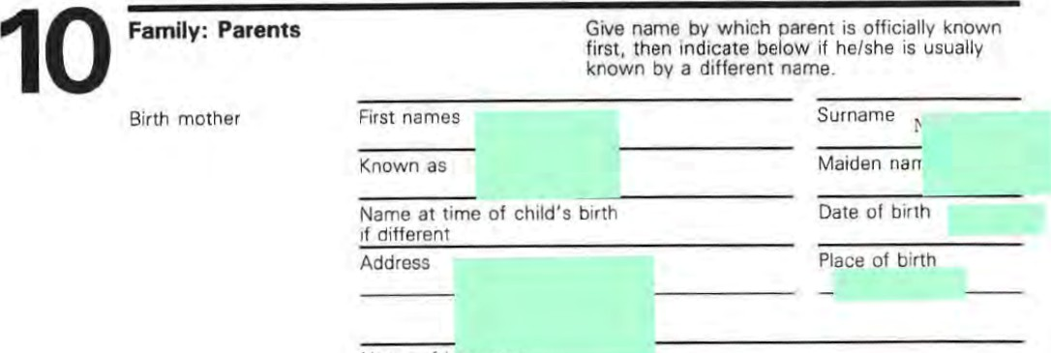
Name of husuuno


Form
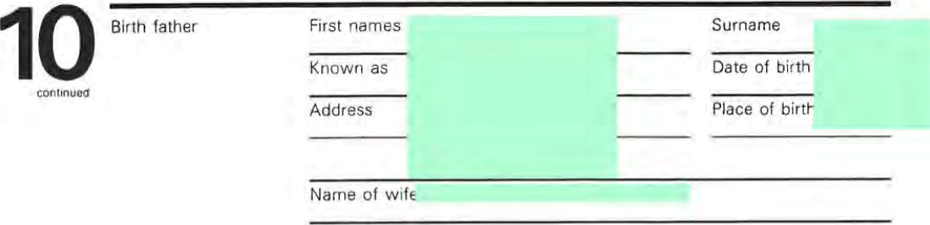

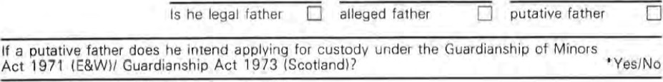If a putative father does he intend applying for custodv under the Guardianship of Minors
Name
of
co-habitee
Current
level
and
quality
of
access
to
child

see note i Brief description
Not available

Birth mother Birth father
Educational attainments
Ethnic origin
Nationality
Religion
Does he!she practise this religion?
AA
Occupation now
Previous occupations
Marital status when Child born
Marital status now
Does either parent have legal custody of the child?
When did they last care for the child?
If someone other than the birth parents is/are legal parent(s), guardian(s) or custodian(sy of this child, give details here or on a separate sheet.
E
(brief summary of the overall plan, including access etc.)
I. To pursue possibility of community parents as an alternative to Residential School. 2. To assæs md provide educational placement in conjunction With family placement which would be outwith normal mainstream education provision. 3. To provide this care up to and beyond 16th birthday to prepare for independant living. a. To reconstitute Peters relationship with both parents and allow him support to renogotiate this.

Date this plan was agreed 25th March 1992

Where was the plan •review meeting fostering panel adoption panel agreed? Other (specify)
Did this include the key person(s) caring for the child? 'Yes/No

It adoption is planned:
I. Give a summary Of any recommendations/comments of the adoption panel and the date Of the adoption panel's recommendation if different trom above.
N/A

2, Date Of agency decision to pursue adoption if different from above. N/A
Do the people caring for the child agree with the plan? If no give details
Mrs Noble agrees with the plan. Mr Noble has been informed in writing of plan and we await his reply.
Is there a time limit by which the child must be moved? It so, specify
Outline any action necessary before the plan can be carried out, (e.g. tracing of relatives, assumption of parental rights. court action, further counselling, preparation of child) and specify who will undertake this.
Following the imposition Of a 44(1) (b) naming Cardross Resources Centre on the 9.4.92 it would seem appropriate Eo review progress made towards finding Community Parents in July 1992 and review plans for Peter in light of the position at that time.

2- Family Finding
What special efforts will be made to find a suitable family for this child? (e.g. referral to a familyfinding agency, publicity campaign)
Referral through Social Work to Regional Family Finding Team.
Have the necessary consents been obtained 1. to the action? • Yes/No
- to the expenditure? •Yes/No

•delete as appropriate continued,.
E

- The child
Does the child know of the proposed plan? If no, give brief reasons
continued

see note k Date the child received writteri information about the proposed plan
Has the child been counselled regarding his/her future? If yes, by whom • ^{es} æcherty Social Worker .

What are the child's views about the plans for his/her future care?
Not sure about future, but willing to try.
Has the child any views about his/her religious or cultural upbringing? If yes, please No |  |  |  | specify.
For adoption placements  N/A | Does the child understand what •adoption/freeingfother pian will mean for him/her?  Does the child understand the legal implications/procedures of adoption/freeing?  If another adoption agency has been working with the child are you satisfied that the requirements in the Adoption Agencies Regulations relating to the child have been met?  Name of social worker/agency |  |  | - Yes/No  - Yes/No  - Yes/No
ParentsJGuardians  Has counselling been given?  Name of social worker and agency (where appropriate) |  | Mother  Yes  JD | Father  No | Guardian
Date written information sent  Does the parent understand the plan for the child and its legal implications?  Does the parent agree to the plan?  Specify any wishes regarding the child's reiigious/cultural upbringing |  | Yes  Yes | No

Will the parent give consent to an adoption/freeing order? • No N/A
Does the parent have access to the child?
Yes Not taken up
Has the local authority terminated access? | No | No
Date parent was notified of the intention to terminate access | N/A | N/A
Has the parent taken legal action?
Outcome of court hearing(s) re access No.
Has legal advice been obtained with regard to the plan for the child? / NO If yes, please give summary of advice and details of any legal action recommended.

E

12 Checklist of additional material
The following shou d be provided with the completed Part 1 of Form E
Date provided Update
For all children Photograph
- Report by person car•ng for child (mav be incorporated in the profile in part 'I)
- BAAF medical Form
C or D and annex
As appropriate 4 Psychiatric report
- Psychologist's report
- Additional specialist medical reports (specify) 7 School report
- Statement under
Education Act 1981/ Record of needs,
Education (Scotland)
Act 1981
- The child's written statement on his/her views about the proposed
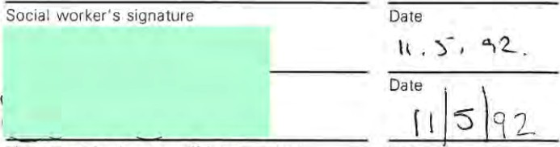
placement/ adoption 13
Signatures
see note m

Link person's signature (if inter-agency) Date

O BAAF 1988
CARDROSS PARK CHILD RESOURCE CENTRE
AMENDMENT TO ASSESSMENT CONFERENCE MINUTE DATED 25 MARCH 1992
SUBJECT PETER NOBLE
- Ms R Casey was present throughout the meeting and should therefore be included in the list of those present.
- Admission to Cardross Park Child Resource Centre took place on
6 March 1992 and not 12 March 1992 as stated in the minute

UUNWhI
ASST OFFICER IN CHARGE
1 4 92
DUNCAN ROBINSON
ASST OFFICER IN CHARGE


Strathclyde
Regional
Council
MAIN ROAD,
CARDROSS
Tel.' Cardross 841031
ASSESSMENT ON
PETER NOBLE (DOB 18 11 77)
2 CEDAR VIEW
ROSNEATH
CONFIDENTIAL
No part may be taken or used without the author's consent.
PETER
NOBLE
2
CEDAR
VIEW
Address
Religion PROTESTANT

6 3 92
Date of Admission

Date Seetion Date Section Date Section
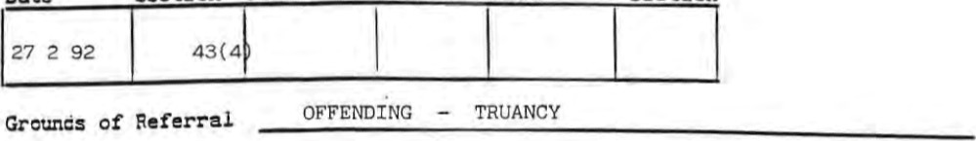

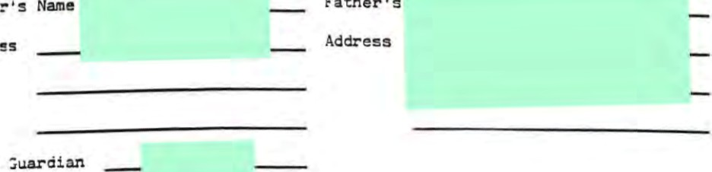
Address
Father

Legzi Suard±an

Details
ADMITTED 6 3 92 on Section 43(4)
4 2 92 Case presented at DASU
(5 weeks) Prior to admission — resident in Blairvadach Children ^{i} s Home Section 15

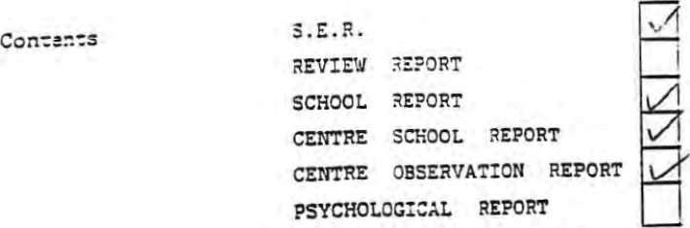
Joe Docherty District
Soc:a.: Worker
Hel ensburgh
Area

Add:ess
CARDROSS PARK CHILD RESOURCE CENTRE
PERSONAL HISTORY PETER NOBLE

18 11 77 Date of Birth
Aug 82 Began formal education John Logie Baird School Helensburgh
1983 Moved house from Helensburgh to Kilcreggan, Peter gubsequently attended Kilcreggan Primary
Nov 87
Aug 88and Peter moved to Rosneath Caravan park to live with
July 89 Peter moved to England first to Carlisle and then Hartlepool to be with his father.
1989 Began secondary education Morton Comprehensive school, Carl Igle
1989 Move home to Hartlepool with father and attended Breaton
Comprehensive School Hartlepool

1990
Mar 91 Peter left England after relationghip difficulties with hig father. Returned to live with his mother. Attended Hermitage Academy Helensburgh
Summer 91 Attended Brucehill IT Project for a 12 week period
Nov 91 and Peter moved into
- 1 92 Peter ran away from home after a breakdown in relationships thin the home
- 1 92 Apprehended by police and received into care (Blairvadach CH) on Section 15 papers
4 2 92 DASU Meeting
27 2 92 Attended Children 's Hearing 43 (4) issued 6 3 92 Admi tted to Cardross for period of assessment
 | Strathclyde  Regional REPORT |  |  | —oate ot Heanng
 |  |  |  | Outcome
 | 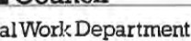 TOTHECHILDREN'SHEARING
Date of Birth
Name

Address School Attended
C/0 2 Cedar View
Hermi tage Academy
Rosneath
Grounds of Referral Religion Theft by Housebreaking
Ongoing contact with Noble family since September. 1991.

 | FAMILY DETAILS |  | Age |  | Relationship to child |  | Employment/School other eg. ATC |  |  | Income and Source
Name
Peter Noble |  | 14 |  | Sub ect |  | Hermi t |  | e Academ

Financial Situation
Psychological
Hermi tage Academy Guidance
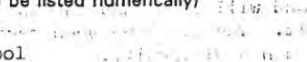  Matters of Particular concern (to be listed numerically)  I Fai lure to attend school  - Offending behaviour  - Relationship with parent and co—hab | Report compiled by  Joe Docherty
Date completed
5 February 1992
 | Date Sent to Reporter
 | Signed
Designati
Social Worker
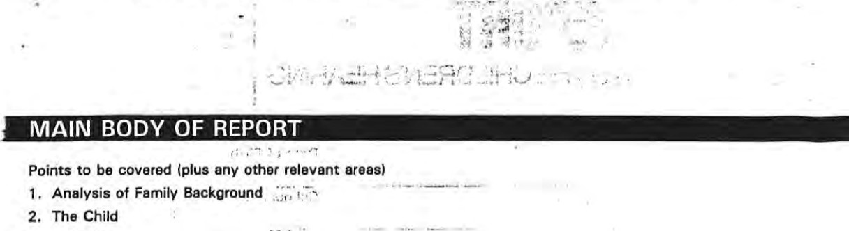
3.
School
4.
Attitudes
to
Grounds
Of
Referral
6. Matters of Particular Concern

6. Assessment and Possible Options
ANALYSIS OF FAMILY BACKGROUND

peter were never able •to -develop an amicable relationship and jccagionally hit peter.
In July 1989 Peter moved back to his father..in Hartlepool and stayed there until March 1991. During that time his relationship with his father deteriorated and he ran away from Hartlepo with his father accusing him of Stealing money from the house and being out of control.
During the period of his absence from Rosneath, and Peter returned to his mother, who was at that time in a very, distressed condi tion. From hig return Peter attended school only sporadically and when spoken to gave assurances that he would try harder to attend. These intentions on Peter's part were never transferred to action.
'HE CHILD
Peter, although he was 14 years old in November 1991 is a tall, well built youth who appears much older than he is. He says that as a result of this and his lack of progress at school, that he is the subject of bullying.
In order to combat this Peter has tended to try and make friends with the older boys who bully him and to maintain this friendship has gone along With almost anything they suggest.
He is at times open and communicative and will state that he understands the nature Of his problem and will take steps to remedy it. The stage between recognising the problem and doing anything to effect change has been his difficulty
Both parents have described Peter as a problem throughout his life and feel that he needs medical help. Mrs Noble has conceded that Peter has not had a stable secure background and that the difficulties she faces with Peter should be seen in a ,wider context.
REPORT TO THE CHILDREN'S HEARING
Peter Noble (cont)
THE SCHOOL
Educational assessment has proved impossible to carry out fully since Peter has not attended school for a sufficient period of time to enable its completion. He does travel in to school on the school bus but more often than not either does not go in or signs in and leaves shortly after. Teachers have found him to be abusive on occasion.
ATTITUDE TO GROUNDS OF REFERRAL
peter states that he and another 2 youths found a key which they thought belonged to the owner of a cottage in Rosneath. He says he knew the cottage to be empty on Friday nights so they went along to gain entry. The key would not open the door and Peter admits kicking the door open. Another youth entered the house and having found a large surn Of money called Peter in.
The boys took the money, shared it out and went on a spending spree in Helensburgh.
He freely admits to his guilt regarding the incident but says he is easily led. This response comes easily to Peter who doesn't seem to consider either the moral wrong of what he is doing or the possible detrimental consequences to himself. He expresses regret at what has happened, but the writer is left wondering about the sincerity of thig expression.
His attitude towards his mother demonstrates a lack of respect for her and authority in general. He seems to have a lack Of understanding or ability to plan for the future and merely reacts to whatever situation he currently finds himself in.
MATTERS OF PARTICULAR CONCERN
I Failure to Attend School
Up to present Peter has consistently failed to attend school on a regular basis. Following the meeting held at school (see school report behaviour) referred Peter to the Divisional Educational Office. He is excluded in the meantime.

2 Offending Behaviour
Peter has been drawn by keeping unsuitable company deeper into situations where he is likely to offend. Apart from the current grounds it has come to the writer 's attention that he has been involved in other incidents which are as yet unsubstantiated. He also has an outstanding charge of resisting arrest.
3 Relationship with parent and co—hab
This relationship at home has completely broken down. On Thursday 23 January Peter ran away from home and was apprehended and received into care on a Section 15 Order on Friday 24 January. He is currently resident in Blairvadach Childrens Home
ASSESSMENT AND POSSIBLE OPTIONS
As previously stated Peter is currently resident in Blairvadach Childrens Home . This department hag contacted the Divisional Education Officer and a meeting has been arranged in Hermitage Academy to explore the possibility of Peter 'g return there with the Social Work Department in loco parentig prepared to sign a guarantee of behaviour.
REPORT TO THE CHILDREN'S HEARING

Peter Noble (cont 2)
It is hoped to use his return to school and residence in Blairvadach to complete a period of assessment and produce a plan for Peter's future in his best interest.
Should thig prove to be too difficult to arrange In Blairvadach we may be requesting the panel to arrange a period of assessment within Cardross .
Joe Dochehty
Social Worker

CardrossStrathclyde
AssessmentRegional
CentreCouncil
unin Road

CARDROSS. Tel. (0389) 841031
Present/ Previous

School Assessment
PETER NOBLE Name of Pupil:

HERMITAGE ACADEMY 18 11 77 School:DoB.:

It would assist us greatly if this Report were available for our internal Assessment

A.S.A.P. Meeting on
Centre Class Teacher: Mr Iain Porteous. Princioal Teacher

Any enquiries may be directed to the Principal Teacher or Class Teacher
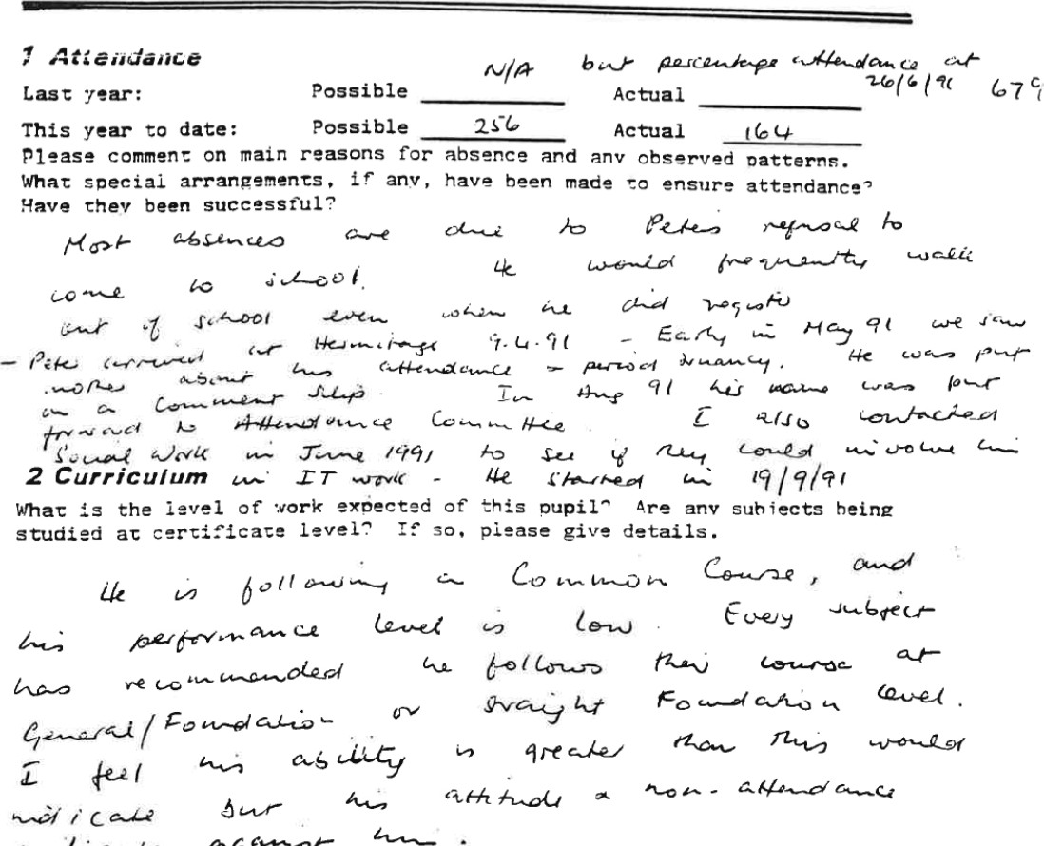
Please comment on main reasons for absence and
What

3 Attitudes
What is the pupil's general attitude to school and school work?
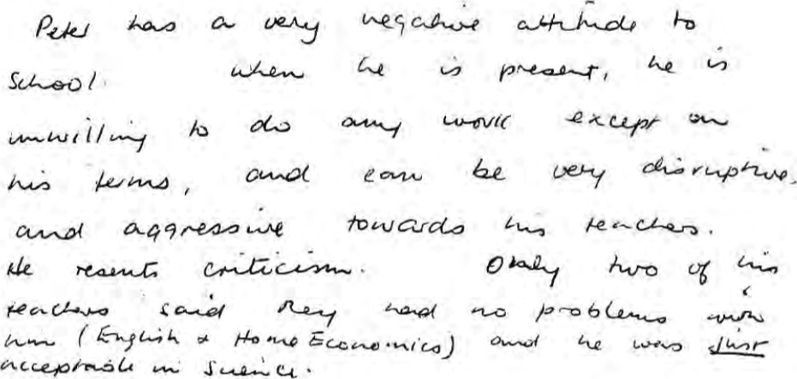

4 Aptitude
Please include details of specific strengths and weaknesses. any remedial or other special help given, and details of sports or practical skills.
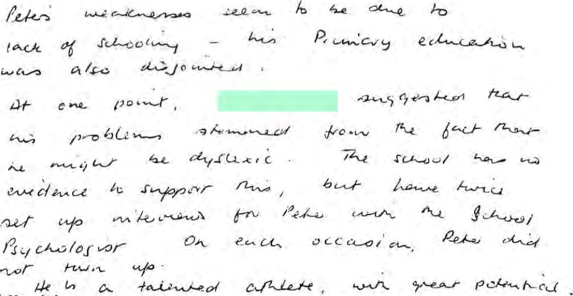

5 Health
Flease inc lade any physical cur restrictions placed on this pupil.
uZ pre LO 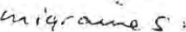

6 Adjustment
With what aspects of school life is the pupil not adequately coping?
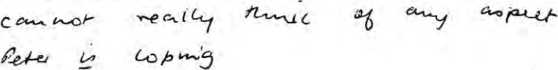

7 Behaviour

Please co—ent on general behaviour In and out of class. and give details and dates of any critical Incidents since admission to the
school •
Please include attitude to adult management and response to controls.
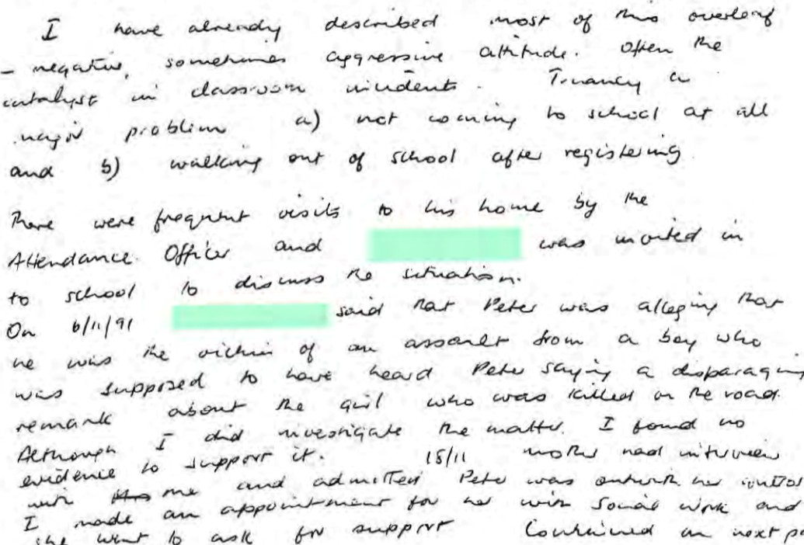

8 Relationships
a) With children: Please mention choice of friends. degree of acceptance, prooiems Of bullying, or any other social difficulties.
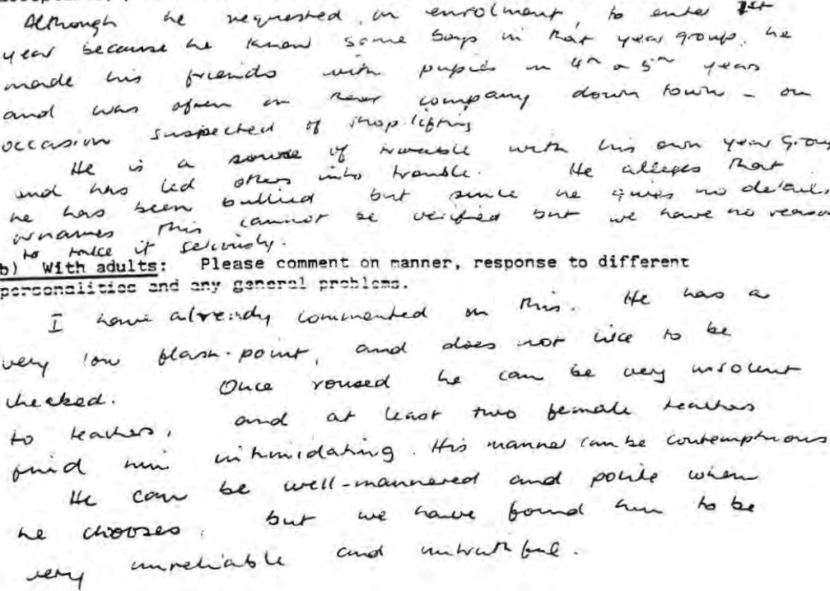

9 Personality
Please give a brief description of the pupiLtg general disposition.
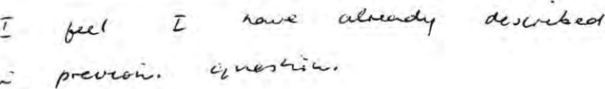

10 Background
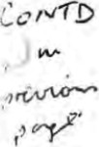
Please give brie(ly information relating to the pupil's background which you feel may be Of help. Please inc lude any known hobbies or outside interests.
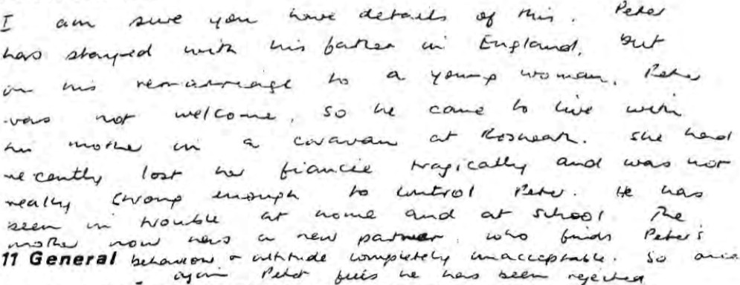

Please use this space to give further information, personal assessments
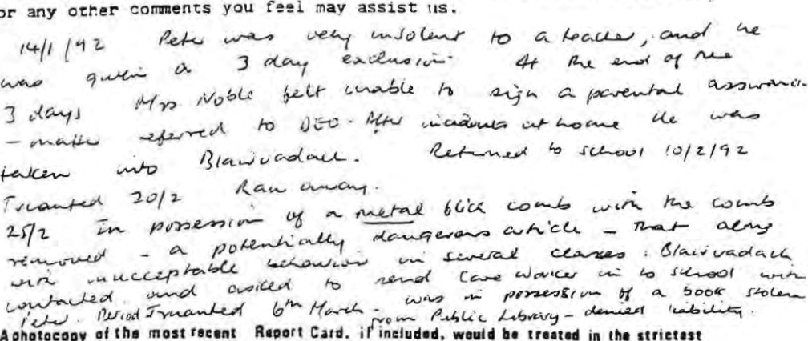A photocopy eoniid•øe• b' the Centro
or
Card.
would
in
striet•st

Oate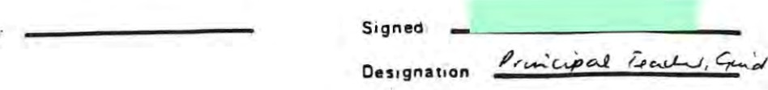
PARK CHILD RESOURCE CENTRE
EDUCATIONAL REPORT PETER NOBLE (DOB 18 11 77)
Chronologi cal . Age 14 years 4 months
Previous School Hermi tage Academy
Date of Admission to Centre School 10 March 1992
INTRODUCTION
Peter appeared a little anxious when he entered the centre school. However, he listened to the instructions on the assessment procedure and settled down to the work tasks that were set for him.
PHYSICAL
Peter Is a tali boy with a good athletic build and has shown particular ability in physical education.
ABILITIES
Peter tends to coast along doing the minimum of work to keep him from getting into trouble .
The quantity of work Chat he produces is poor and the quality could be better.
His attention span is quite short and will engage in conversation with the other children in his class keeping them off their work.
In number skills, Peter has a grasp of the four standard operations for combining numbers, although he is not sure of the multiplication tables. When given assistance he can identify the mathematical strategy to solve problems in the written form, however, he does not always know how to apply the principle. Peter is good on mental ari thmetic and tends to do most mathematical calculations in his head. Peter does, however, struggle with percentages, measuring angles and social mathematics .
In oral language Peter is articulate, has a good vocabulary and is quite able to express himself and maintain a logical conversation.
His reading is fluent and he is able to accurately identify the main concerns of the text. He is also able to state accurately, not always in his own words, individual items of information retrieved from the text. Peter's creative writing is fairly well organised but his vocabulary is restricted which limits his possible range of expression. This is possibly linked to Peter's poor spelling, he tends to spell words phonetically without regard to spelling rules .
His sentence structure tends to be quite restricted and he pays little attention to the use of punctuation marks .
In his other subject classes he is found to be easily led by his peers result—
ing in disruption in class work and he allows others to make decisions on his behalf which has a detrimental effect upon his class work.
He has shown a particular interest in physical education and performs well in this subject.
BEHAVIOUR / •
2
PETER NOBLE (CONTINUED)
BEHAVIOUR
Peter absconded from the centre school on 16 March 1992, with another boy from a subject class and was later returned to the centre by the Clydebank police.
Peter is seen as having a IOW level of stability with no guarantee of his behaviour or attitude. He is also seen as being pleasant and co—operative when it suits him.
SOCIAL / PERSONALITY
Peter has made some friends since his arrival at the centre school. He enjoys the company of the other children and it is important to him to be 'one of the boys . He is aware of what is going on around him and tends to get involved in issues which bear no direct relation to him.
Peter has a warm, friendly side to him and he has a good sense of humour and he also likes to be the centre of attraction.
Peter tries to put on a front to give the impression that he is 'super cool and full of confidence whereas, he seems to have a low self esteem and lacks confidence in hig own abilities. This was demonstrated in the physical education class.
Due to Peter's height he gives the impression of being rrore mature than his chronological age would suggest and is treated as such resulting in more being expected of him. He is perhaps immature in his moral development.
Peter has been warm, friendly and co—operative in his attitude towards teaching staff.
ATTITtJDE
Peter is aware of the reasons that brought him to Cardross Park and states that he feels bad about the whole situation.
He puts forward as the reason for his offending as wanting to be 't one of the boys" and finds it difficult to say no when peer group pressure is applied. Peter admits that he lacks confidence in himself and Is easily led by others.
Peter freely admits that the relationship with Mr Hendry is non—existent and he is not prepared to try to improve the situation.
His relationship with his father is dismissed by Peter as "so so ^{ft} and does not see his future being with him.
Peter's relationship with his mother means a lot to him and he would like to return home to be with her on her own. He feels bad about upsetting his mother and is aware of doing this to her.
His attitude to the centre school has been fairly positive stating that he enjoys the centre school 's less formal approach.
He has stated that he does not want to return to Hermitage Academy and feels that if he went to another mainstream school he would try harder. It is Peter's intention to leave school when he becomes sixteen years old.

Peter / •
3
PETER NOBLE (CONTINUED)
Peter does not appear to fully comprehend the effects of his actions on others and himself. He pays little attention to the consequences of his actions. He hag stated that his main fear is being sent to a List 'D' residential establish— ment and states that he will run away if placed in one.
Peter would like to be a long distance truck driver as he enjoys travelling.
CONCLUSION
Educationally, Peter has some weak pointg in number work and in language skills which require to be addressed.
Presently, Peter might not gain fully from returning to a mainstream school, his needs might be better addressed through a small group teaching setting.

JOHN HENDERSON | IAIN S PORTEOUS
CLASS TEACHER  23 3 92 | PRINCIPAL TEACHER
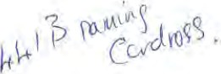
 -Ilk
CARDROSS PARK CHILD RESOURCE CENTRE
ASSESSMENT REPORT PETER NOBLE (DOB 18 11 77)
2 Cedar View
Rosneath
GROUNDS OF REFERRAL
- Family — Relationships within the family have broken down
- Offending — Peter has accumulated a number of charges in recent months
- School — Truancy / behaviour
REACTION TO ADMISSION
Peter was admitted to Cardross Park Child Resource Centre under Section 43(4) of Social Work (Scotland) Act 1968 on Friday 6 March 1992. Peter was accompanied by Jan McQui11an, a member of staff from Blairvadoch Children 's Home. During the admission process Peter was very pleasant and co—operative. After documentation procedure was completed, Peter settled quietly with the other residents for his first evening in Fruin unit.
PERSONALITY AND BEHAVIOUR
Peter has shown himself to be a friendly and likeable young man, consistently displaying an extremely sociable nature and many positive personality traits.
He is an able conversationalist and enjoys participating in discussions. He has a wide range of interests and likes to speak about them, and in general displays a respect for the opinion of others.
Peter gives the impression Of being older than his fourteen years. This impression is initially suggested by Peter's physical appearance and is compounded by his ability to interact comfortably with both adults and other residents . Peter hag stated that although he does feel older than his years he is also aware that others have higher expectations of him that he cannot always live up to.
On occasion, staff have observed Peter indulge in immature behaviour. At these times his behaviour deteriorates into childish, crude jokes and comments. It
D would appear that so long as he has an audience he will slip into this type of behaviour. When spoken to about this inappropriate behaviour, his reponse is to assume a rather arrogant demeanour. This type of situation has not proven to be extremely persistent or problematic during Peter's stay but is indicated here to highlight the confusion experienced by Peter because of the raised expectations of others.
Peter fully understands the reasons surrounding his reception into care. He has no difficulty in discussing these events and is open and responsive to questions on the subject. Nevertheless it would be fair to say that Peter is extremely unhappy about his present circumstances .
The highly structured regime and level of staff presence has left Peter feeling cooped up and confined' • Even although he relates well to the staff group he does resent the lack of space' . He is well aware of and understands the reasoning behind the controls but is reluctant to wholly accept our legitimacy. Generally Peter displays a cool facade in order to disguise his insecurities and fears. But on occasion his frustration is evident and is generally displayed by a sullen, tense expression.
It /
2
PETER NOBLE (CONTINUED)
It is recognised that with regards to his situation and future Peter hag felt at rock bottom during his stay here. This was very evident on hig return to the centre after he absconded from Centre school. He returned to the centre on the same day he left and was emotionally at a very low ebb.
RELATIONSHIP WITH PEERS
In general Peter has chosen not to become too involved with members of the group. On arrival he spent most Of his time with a female member Of the group but even this cooled off fairly quickly. He hag tended to isolate himself but nevertheless in spite of this solitary stance he hag established himself as top Of the pecking order.
This 'status' has been easily achieved as within the present group there is basically no competition. It has been suggested that if the composition of the group was different then a more anti—authoritarian side to Peter may have been evident. However, Peter has been observed being manipulative, with this verging on him bullying younger, less able residents just a touch. Fortunately this has not been a serious difficulty and it must be acknowledged that there has been scope for Peter to be more forceful and he hag not capitalised on this.
In general Peter has displayed a capacity for being amiable and has shown that he possesses an even temper and a sense of humour. Unfa•tunately this has on occasion deteriorated and he has acted immaturely by humiliating others in the group to amuse himself. On the other hand he has shown that he can also be patient with the limitations of others . In fairness to Peter it would appear that the sense of confinement combined with the 'wearing' behaviour Of other members of the group has put his tolerance to the test.
RELATIONSHIP WITH STAFF / MANAGEMENT TECHNIQUES
From the outset Peter had no difficulty in communicating with staff, and, in general approached them in a mature manner. It has been noted that throughout his stay he hag questioned the majority of existing rules and regulations regarding behaviour and routine. However, as he has generally complied, albeit with
D a moan and sometimes a degree of reluctance, it would appear that he was establishing ground rules rather than challenging authority.
Although Peter has occasionally displayed an arro*lt demeanour he is more inclined to be polite and pleasant with staff. Most staff have enjoyed a fairly constructive relationship with Peter as he has been confident and relaxed in engaging staff in conversation, and has openly discussed the events which proceeded his reception into care.
Peter has not presented any management problem during his Stay and although questioning of structures and boundaries of unit life he has never made attempts to push the limits It Is probable that complaining has been his much needed release valve It is difficult perhaps for Peter to see his stay here in a positive light in view of his circumstances.
HEALTH
During his stay in Cardross, Peter has enjoyed good health. He is very particular in his appearance and has maintained a high standard of hygiene. Peter's high level of physical fitness is obvious and he is keen to participate in energetic activities e.g. football and swimming.
PETER'S /

3
(CONTINUED)
PETER'S VIEW / CURRENT SITUATION
Peter fully understands the reasons surrounding his reception into care. He has no difficulty in discussing these events and is open and responsive to questions on the subject. Unfortunately he does not appear to display a great deal of regret for the offences he has been involved in, tending to stress the point that he was 'easily led' ,which he appears to see as lessening his responsibility. On the other hand when Peter is speaking Of his family It is evident that he hag genuine affection and concern for them — especially his mother and does experience remorse for the upset his actions have caused.
Although Peter's first choice regarding future plans would be to return home he is mature enough to accept that this is not a realistic option. Alternatively Peter has proposed that he resides in a children's home and attends mainstream school . Peter level Of commi tment to this proposal may indeed be questionable but this remains to be seen.
Mrg Noble's contact with peter during his stay has been minimal. She has shown interest in but no commitment to Peter's future plans. When given the opportunity to speak with staff she has chosen not to. This situation has led to obvious difficulties and has limi ted the options available and has hindered the assessment process.
CONCLUSION
Although Cardross would not have been Peter's first choice of residence, he has æcqted the situation with a degree of resignation. Also, it must be appreciated that Peter is extremely unhappy about his overall circumstances . During his stay Peter has responded positively to the adult support if not the structure of the centre but this reflects events and experiences of the past.
Peter has qualities of control and maturity which could be developed to his advantage and it is Important that these aspects and Peter's own proposals be addressed at conference .
ROSE CASEY MARION FOX
ASST ASSESSMENT OFFICER A/SNR ASSESSMENT OFFICER
23 3 92
CARDROSS PARK
SUMMARY AND RECOWMENDATIONS OF ASSESSMENT CONFERENCE HELD AT CARDROSS PARK CHILD RESOURCE CENTRE ON WEDNESDAY 25 MARCH, 1992. BETWEEN 11 am and 12 NOON
SUBJECT: | PETER NOBLE (DOB 18 11 77) 2 Cedar View, Roseneath.
PRESENT | MrD Robinson Assistant Officer in Charge, Cardross (Chair) Mr D Burke Area Manager, Helengburgh
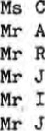
Main p. T, Guidance, Hermi tage Academy
McCallion — Assistant Assessment Officer, Cardross
Conway Assistant Officer in Charge, Cardrogs (minute )
Henderson Teacher Cardross
Smi th Officer in Charge, Blairvadach Children ^{I} s Home Docherty Social Worker, Helensburgh.
APOLOGIES ; J Nee Senior Psychologist
Peter .ioined the meeting after reports had been read.

Mr Robinson explained the purpose of the meeting and the manner in which it would be conducted. He emphasised the importance of participation on
Peter's part and urged him to make his thoughts and feelings known. Mr Docherty was asked to give a brief account of the circumstances leading up to peter's admission to Cardross. The three main areas were failure to attend school and behaviour during periods when he did attend, behaviour within the community and his mother's inability to exert control, The Social Work Department were of the opinion that the possibility of working with Peter in the community still remained. However i the relationship between and Peter had reached the point where a return home could not be considered. Peter attended a Children's Hearing, the outcome of which was that Residential
Assessment be undertaken. Peter ran off and was placed in Blairvadac•h Children ^{i} s Home after apprehension until such times as a vacancy occurred at Cardross. He was admitted to Cardross on 12 March, i 992.
Ms Main stated that Peter soon began to identify with older boys Who were truants and such behaviour became part and parcel of the manner in which he operated. He would not accept school rules. Mrs Noble was involved With the school quite a lot but came to the point where she was unable to control his actions resulting in the School referring the case to the Social Work Department.
At Blairvadach Peter did not present any great management problems. He did fit in reasonably well and was fairly popular, although it was recognised that he did not have any real competition because of his physique. The younger children tended to 100k up to Peter and, in fact, accompanied him on occasions Of absconsion.
The Centre School reported that Peter was a bit anxious initially. However, he has responded fairly well apart from being a bit chatty at times, to the distraction of others. He has some problem with number work but, given assistance he can carry out and complete set tasks. His spelling is poor and this has an adverse affect on his written work. Oral cormuni cation presents no problems and he can draw things out to a satisfactory conclusion. Within the Centre School, Peter has displayed behavioural stability although it was felt that he could be easily led which could result in a change of attitude. He appears to enjoy Cardross although he maintains he wants to be with his mother, a move which he realises is not feasible at present.
Within/. .
2
Within the unit there has been no problem regarding Peter remaining within the structure and strictures Of residential life. He has never lost control, but has, on occasion, cast an angry look or mumbled under his breath when remonstrated with. No serious incident has occurred and he has backed off each time when confronted. In many ways he has been an asset to the group and his relationships with staff is good. He is honest when discussing his situation and appears to be able to grasp and acknowledge the reality Of his situation. Mrs Noble has been in touch by telephone but has not visited.
Although Mr Nee could not attend the conference he did share some thoughts with Mr McCall ion. He also feels that Peter has a good grasp of where he is at present. He would like to move from this posi tion either by moving back in time or moving forward a few years into adulthood. Resurrection of parental contact is very important and should be worked at as quickly as possible. Mr Nee suggested that moving towards residential care would not be helpful at this time.
General discussion covered consideration of various resources including Children's Home, Residential School, Fostering and Community Parents. The first two options were not seen as appropriate at this point in that mainstream school attendance would be a requirement with regards to Children's Home placement and peer group composition would be a detrimental factor in the case of residential school. Peter's frustration could be increased by the pressure due to mainstream school structure and it was felt thät he had been in care such a short time that the Social Work Deparmtent has not had space to work alongside him, which would be denied to a great extent by residential school placement . Working towards bringing together Peter and his parents was seen as extremely important and it was therefore dust as important that placement with a family wag not viewed as a replacement family. Because of this the meeting were of the opinion that Community Parents be sought as opposed to Foster Parents.
The following areas were identified as requiring further investigation before a definite plan can be formulated
- Clarification regarding the feasibility/ availability Of obtaining Community Parents.
- Attempts to be made with a view to getting mother and son together, difficult as that may be.
- Discussion with Mr Nee to ascertain what could be arranged to meet the need for alternative education.
Those present agreed to reconvene on Thursday 7 May, 1992, at 11 am when, hopefully, sufficient information will be available to enable a sound recommendation to be made.
As an interim measure, Conference would respectfully request that Peter be returned to Cardross on a Residential Supervision order when he appears before the Hearing on 6 April, 1992.
Peter will remain at Cardross on a voluntary basis until the Hearing takes

place .
RON CONWAY
ASSISTANT OFFICER IN CHARGE DUNCAN ROBINSON
ASSISTANT OFFICER IN CHARGE

CARDROSS PARK
MINUTES OF ASSESMENT REVIEW MEETING HELD AT
CARDROSS PARK CHILD RESOURCE CENTRE ON THURSDAY 14th MAY 1992
Child's Name: | PETER NOBLE (0.0, B, 18.11.77)
Present: | Rita Bannon | S. A.O. Cardrogs Park (Minutes)
 | Joe Docherty | S.W., Helensburgh Area Team
 | Helen Muir | A.D. O. (Child Care) Dumbarton District Headquarters
 | Duncan Robinson | A.O. I . C. Cardross Park (Chair)
 | David Burke | Area Manager, Helengburgh
 | Ann Gillespie | A. A. O. Cardross Park
 | John Henderson | Teacher Cardrogg Park
Apologies : | Joe Nee | Psychologist
At the last meeting held on 25th March 1992 tasks were set:
Clarification regarding the feasibility/ availability of obtaining community parents.
2. Attempts to be made with a view to getting mother and son together, difficult as that may be.
3, Discussion with Joe Nee to ascertain what could be arranged to meet the need for alternative educazion.
Within the centre, Peter has progressed both in the unit and in school. He has a positive attitude to his schoolwork and takes part in all subjects and activities. Peter relates well to adults and children and has kept out of any trouble or bad behaviour within the group.
There was concern expressed at the last meeting about Peter 's ability to cope with mainstream education and the need for possible specialised resources was discussed. Teaching staff at Cardross and Peter agree that
•he could in fact cope in a mainstream setting.
Joe Nee has visited Peter in the Centre and has not assessed any need for specialised education and has pointed out that perhaps education is not the priority need inPeter's life at present.
David Burke expressed strong concerns about Joe Nee's contribution as he was of the opinion that educational provision should have been identified by Nee.
The paperwork for application for community parents has now been completed and will be passed to Farnily Finding. Helen Muir stated the application seems appropriate but informed the meeting that timescales are difficult to predict and placement could take up to twelve months
Peter's contact with his mum has been, apart from one visit at the Centre, limited to phone calls.
Joe Docherty suggested that and that Peter could now only rely on phone contact with her.
Peter stated quite clearly he did not want any contact with his father
2.
(Continued )
After a discussion on options available/ appropriate all present were of the opinion that Peter should return to mainstream school and be placed in a local children's home while awaiting placement with community parents.
To assist and support Peter in a return to school Rosemary Finnigan (Y.P.I.T. Project) will be asked to become involved ag ghe has links with local schools.
Peter will be encouraged to pursue interegtg outwith the centre and join a youth club etc .
A Child Care Review will be arranged around mid June when timescales for placement with community parents and Peter' 3 commitment to attending school should be clearer. This would then a33i3t in planning for a Children's Home placement.
R. Bannon, D. Robinson,
Senior Assessment Officer. Assistant Officer in Charge CARDROSS PARK
PANEL REPORT on
PETER NOBLE (DOB 18 11 77) 2 Cedar View, Rosneath
ADMISSION/PRESENT SITUATION
Peter was admi tted to Cardorss Resource Centre on Friday 6 March under Section 43(4) of the Social Work (Scotland) Act, 1968.
GROUND or REFERRAL
I Breakdown of family relationships 2 Offending wi thin the community.
3 Truancy from school/behaviour in school .
On his admission to Cardross, Peter was resident in Fruin Assessment Unit. At the Assessment Conference on 25 March, 1992, it was agreed by all present, that more time was required to allow further investigation into certain areas before a definite plan could be formulated.
AREAS TO BE INVESTIGATED
- Clarification regarding the feasability/availability of obtaining community parents
- Attempts to be made with a view to getting mother and son together.
- Discussion with Joe Nee, Psychologist, to ascertain what could be arranged to meet the need for alternative education.
It was agreed to reconvene the meeting on Thursday 4 May.
Peter attended a Children's Hearing on 6 April, 1992. It wag the panel decision that Peter return to Cardross on a residential supervision order.
Shortly after his Hearing Peter was transferred within the Centre to Carman Holding and Preparation Unit. This would allow for an individual care plan to be drawn up for Peter. The remit of Carman would easier facilitate the formulated plan.
Due to unforeseen circumstances the assessment review scheduled for 7 5 92 took place on 14 5 92.
The decisia-s of the Review were as follows.
I Peter to return to mainstream school, namely, Our Lady and St Patrick's High School, Dumbarton.
- Work with Family Finding Team would be ongoing.
- Children's Homes would be investigated as an interim placement.
- A further Child Care Review would be arranged to assess Peter's commitment to formulated plan.

A Child Care Review was held on 23 9 92 and discussed the progress Peter had made, both within the Centre and at Our Lady and St Pat's Secondary School. It was agreed by all present that Peter had made considerable progress in both these areas, in his attitude within the Centre and in his commitment to attending school.
Although the workers from the Family Finding Team were still actively pursuing a suitable place for Peter, it was the opinion of the meeting that the interim place wi thin a Children's home suitable to Peter's needs be investigated as soon as possible. Joe Docherty, Social Worker, agreed to present Peter ^{I} s case at D.A. S. U. at the first available opportunity. He would also investigate appropriate children' s homes.
Immediately after Peter 's case was presented and plans approved by D.A. S. U. , Joe Docherty informed us that a possible place may become available at
Burnside Children's Home. This was thought to be suitable to Peter's needs .
The location would allow Peter to continue his education at Our Lady and St Patrick's. It would also allow Peter to maintain the friendships he had built up in the area.
After a meeting with Joe Docherty and staff at Burnside, it was agreed that it might be appropriate, subject to panel decision, for Peter to take up residence with them . A plan was formulated which would allow Peter to have weekend leave prior to the Hearing and possible admi i on.
RELATIONSHIP WITH PEERS
Peter has proved to be a popular member of his peer group. Al though on the surface Peter would appear to be isolating himself from his peer group, it does not detract from his popularity. This could in part be due to Peter's stature and calm manner. He does not appear to feel under any pressure to prove himself.
Peter is quite friendly and open to other residents but does not appear to try and cultivate any special or close relationships. He did form a friendship with a particular boy, who left the Centre some time ago to return home. He has maintained this friendship albeit on a fairly irregular basis.
RELATIONSHIP viTH STAFF/MANAGEMENT
Peter has presented as a friendly and likeable young man. He is fairly confident in his approach to staff, both male and female, and can communicate in a fairly mature and articulate manner.
Peter is relaxed and open in discussion with staff about his past and present si tuation. One almost feels he is looking for some kind of clarification as to why all the events in his past happened to him. Was it all his fault? There are occasions when Peter can be quite demanding and childish. When reprimanded he can be quite arrogant and cheeky. These occasions which were rare in the past have recently become more frequent. On talking to Peter one gets the impression that it is total frustration of his situation that is making him more susceptible to mood swings .
On the whole Peter has presented no real management problems during his stay here. On most occasions he is compliant with the structures and routines of the Centre. There are , of course, times when he will test to the limit any restrictions or rules which the staff may try to enforce.
PERSONALITY/BEHAVIOUR
Peter has shown himself to be a presentable and sociable young man with a pleasing personality. Although only 14 years old his physical appearance and manner would suggest he was somewhat older than his years.
On occasion Peter will lapse into really childish behaviour. This usually takes the form of silly or crude comments to an all too receptive audience . When reprimanded he will become withdrawn and sulky. These moods however rarely last very long. One rather disturbing facet of Peter's behaviour which causes concern, is the amount of lies he can tell and how easy they appear for him. It becomes very obvious when peter wishes to spend time outside the Centre with a person:ox• persons he knows will not be thought of as suitable companions by those involved with and concerned about his welfare.
HEALTH/HYGIENE
During his stay in Cardross Peter has enjoyed reasonably good health . He is very particular about his personal hygiene and needs no pressure put on him to bathe daily. Like most teenagers however he is extremely untidy and has to be constantly reminded to tidy his belongings .
INTERESTS
Peter is an extremely physical young man. He enjoys most sports but is particularly keen on running.
He has quite recently joined a local boxing club. Peter appears to enjoy it, both for the sport and not least for the opportunity to involve himself in the community.
On two occasions this year Peter has had the opportunity to go on a trip with the Ocean Youth Club which he thoroughly enjoyed.
FAMILY
PETER'S VIEW
Although in the past Peter was fully understanding Of the reasons behind being in Care, or to be precise, Cardross. He is finding it more and more difficult to understand why he is still here. He feels as though he has been let down in the past, and all the plans were simply just words on paper. In his mind nobody actually appeared to be doing anything.
He/ . . .
He is extremely pleased, though understandably nervous about the latest developments involving Burnsi de.
Although Peter's ultimate aim would be to return home, he is aware how unrealistic this is. Therefore a move to a Children's Horne and eventually cornhunity parents is at this time quite acceptable to him. Peter is aware that only his own commi tment to this plan can bring about its success.
CONCLUSION
During his stay at Cardross it has to be noted Peter has accepted the situation with a degree of resignation, which would suggest a maturity beyond his years. Although he hag responded positively on most occasions, it is becoming pretty obvious that Peter requires to be in a position where he would be able to take more responsibility for his own I Ife. This would of course need to be in conjunction with a degree Of structure and support. Given the appropriate opportunities Peter will hopefully respond and will eventually be a responsible member of any community he wishes to be part of.


ANN GILLESPIE | MARION FOX
ASSISTANT ASSESSMENT OFFICER | A/SENIOR ASSESSMENT OFFICER

26 10 92

CA'RDROSS PARK CHILD RESOURCE CENTRE
CENTRE SCHOOL
POST ASSESSMENT PROGRESS / REVIEW REPORT SHEET (GENERAL SUBJECTS)
GENERAL SUBJECTS TEACHER JOYN H ^{I}?NDERSON
PUPILS NAME PETER NOBLE REVIEV DATE : 7 5 92 AGE .14yrs . 5mthS
FUTURE PLACEMENT PLAN •
PR10RITY AREAS IDENTIFIED FOR DEVELOPMENT | PROGRESS IN EACH AREA
Number Work  Multipl ication Tables  Graphs  Percentages  Measuring Angles  Social Mathematics  Language Work  Spelling  Behaviour  Activities outvith the  Centre : —  Undet, 16' s Rugby | Peter had forgotten much Of the basic rules for multiplication through the lack of practice. He has been practicing his tables of multiplication and has shown progress in thig area.  Peter is more familiar with the concepts of bar graphs and plotting co—ordinates and is able to draw and interpret graphs .  Further progress in these areas have been prevented due to Peter absconding from the centre school and following a work programme in his room .  These areas will be followed up now that Peter has returned to the centre school.  A spelling correction book has been set up to enable Peter to note words which he spells incorrectly and spelling reviews can be carried out to check up on his spelling .  peter has moved into the English extraction class where he will be able to work at Standard Grade English Level  After Peter ^{t} s assessment conference he and another boy absconded from the centre school and were later returned. However, they both absconded again and were return to the centre once again .  Since this episode Peter has not given any cause for concern at the centre school  Peter was taken to join an under 16' s Rugby Team. Peter performed well in thig situation and integrated well into the team. He showed commitment and enthusiasm and was well received by all the other team members.

SIGNEE
GENERAJSUBJECTS TEACI--ER
CARDROSS PARK CHILD RESOURCE CENTRE
REVIEW REPORT PETER NOBLE (DOB 18 11 77)
2 Cedar View
Rosneath
Previous assessment conference held in Cardross 25 March 1992
Decisions as follows : —
- Clarification regarding feasibility/availability of obtaining community parents.
- Attempts to be made to strengthen mother/son relationship .
- Meeting to be art•anged with Joe Nee, educational psychologist, to ascertain what could be arranged to meet the need for alternative education.
Since the assessment conference held on 25 March 1992, Peter attended a panel on 6 April 1992, at which the decision tAcenvnsto return Peter to Cardross on a Residential Supervision Order. He remained in Fruin assessment unit until a place became available In Carman, holding and preparation unit, on 21 April.
The transfer to Carman unit was considered to be a positive step for Peter. Firstly, it would provide him with the opportunity to build up his independence and secondly, help to prepare him for his eventual future placement.

Peter settled well into Carman. He enjoys the slightly more relaxed atmosphere within the unit. He is aware however that the same basic rules and controls are operative throughout the centre . Peter interacts well within the peer group. He is a popular asset to the group and will involve himself in most activities . Peter's height and stature usually places him near the top o? the pecking order within his peer group. To his credit though he does not use this negatively i.e. bullying.
Peter presents as a pleasant and articulate young man. He shows no preference for male or female, seemingly at ease with both. He enjoys individual attention and will discuss his situation in a mature and sensible manner.
He appears to have made some progress in that he realises he is ultimately responsible for his own actions.
To date Peter has caused no management problem. He accepts the rules and regulations necessary to the efficient running of the centre, though not always wi thout question.
Peter enjoys the activities on offer within the centre i.e. football, pool, table tennis . He also enjoys and fully participates in outings to swimming or any other activity on offer outwith Cardross He has expressed a keen interest in running and given the opportunity would possibly take it up seriously as he states that he has been involved in competition running previously .
FAMILY SITUATION
Peter does not talk a lot about his family. When he does it is obvious he has a genuine affection for them. He is particularly concerned about his mother and is remorseful about any upset he may have caused her through his actions .
Due/ • •
2
PETER NOBLE (CONTINUED)
Due to the situation at home there has not been a great deal of contact, although Mrs Noble does try and telephone him when possible.
PETER' S VIEW
Peter resents being in care but fully understand the reasoning behind his being here. He sees his future with community parents because he feels he has no other option apart from remaining in care.
He is aware this could be a long term solution for him and is anxious about what could happen to him in the short term.
He enjoys living in this area and has suggested several times that he would like to have another chance at living in Blairvadach Children 's Home.
He is aware of the stresses this would place on him regarding the peer group pressures he has experienced in the past and given in to. He is adamant however he could now cope .
CONCLUSION
Although Peter has coped extremely well within Cardross, given Peter's past history it would be unrealistic to expect him to cope on the same level for an unlimited period of time .
It would therefore be in peter's best interest that an alternative placement be identified as soon as possible.
The options available will hopefully be addressed at review .

ANNE GILLESPIE | MARION FOX
ASST ASSESSMENT OFFICER | ASSESSMENT OFFICER

12 5 92
CARDROSS PARK CHILD RESOURCE CENTRE
REVIEW REPORT on
PETER NOBLE (DOB 1B 11 77) 2 Cedar View, Roseneath
Section: 44(1) (b) Cardross
Last Review: 14 5 92
DECISIONS
I Peter to remain in Cardross.
- Community Parents — To await outcome of screening meeting.
- Mainstream schools to be investigated
- Pursuits outwith Centre to be pursued.
Since the last review Peter has started attending Our Lady & St Pat's. Ini tially Peter had problems in settling into the routines necessary for attending mainstream school. However, he overcame this, and, according to reports received, responded well to school routines and discipline.
Unfortunately on 14 September, 1992, an incident occurred within the school which resulted in Peter assaulting another pupil and he was subsequently suspended for a three day period.
Within the Centre Peter causes no management problem. which is to his credit given the length of time Peter has been resident here and the emotional pressures he is under. peter has been rather subdued lately, this possibly due to the fact he does not see that there has been any progress made regarding community parents or an interim placement.
Peter had a visit from Alex Neil, from the Family Finding Team, he did not show any real enthusiasm after this visit since he was of the opinion that it was just more talking and no real action.
It has proved difficult to get Peter interested in any activity outwith the Centre, which he would have to attend on his own. He felt rather vulnerable, having to face yet another strange situation on his own. Recently, however, he has started attending a boxing club in Renton Youth Club. He is attending in the company of a friend from school. The boy's parents are aware of Peter's present circumstances and are agreeable to Peter accompanying their son and have also very kindly asked Peter to tea in their home one night per week.
FAMILY SITUATION
Due to Mrs Noble's present circumstances she finds it difficult to visit Peter. She does however telephone whenever possible, and Peter really looks forward to these telephone calls.
Peter still finds it extremely difficult to accept what he sees as his mother's rejection of him. He also finds it very difficult to discuss the situation, putting up a very defensive front whenever the subject is broached.
Although/
2
PETER NOBLE
Al though in the recent past Peter has been adamant about not wanting to contact his father, he is now stating he will write to him to see if he will offer him a home. This more than anything would emphasis how dejected Peter is feeling at this moment.
CONCLUSION
At this particular time Peter is finding it difficult to accept his present situation. He is of the opinion that no one is making any real effort on his behalf. rt is the writer's opinion that Peter needs can, to a limited extent, orl'-—t be met at Cardross. Therefore the review mugt address the need for Peter to progress from Cardross, and discuss the options available,

ANNE GILLESPIE | THOMAS P KELLY
ASSISTANT ASSESSMENT OFFICER | A/SENIOR ASSESSMENT OF#ICER
18 9 92

