PRIVATE AND CONFIDENTIAL Please ask for Ross Fairfield

Ms Rebekah Ditcher | Email: healthsocialcarerecordssupportteam@highland.gov.uk
Aiker Legal | Our ref: FS-Case: 774840118
 | Your ref:
 | Date: 16th January 2026

Dear Ms Ditcher

Subject Access Request
Many thanks for submitting a subject access request on behalf of your client Richard Garrett, which was received by the Records Support Team.
I have enclosed the information requested however due to data protection regulations (UK GDPR) third party information including where applicable, police and NHS, has been redacted. Where possible, I have left references available to allow you to seek this information from the relevant organisation.
A link to the electronic information will be sent out shortly after you have received this e-mail. If for any reason the shared link is not visible in the e-mail account provided, it is advisable to check your SPAM folder in the first instance.

If I can be of any further assistance, please do not hesitate to get in touch.

Yours sincerely
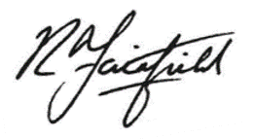

Ross Fairfield

Records Support Officer
Records Support Team
Health and Social Care

